**PROJECT 3**

Name: Shivani Poovaiah Ajjikutira

Email ID: [sajjikut@andrew.cmu.edu](mailto:sajjikut@andrew.cmu.edu)

1. **Task 0 Execution**

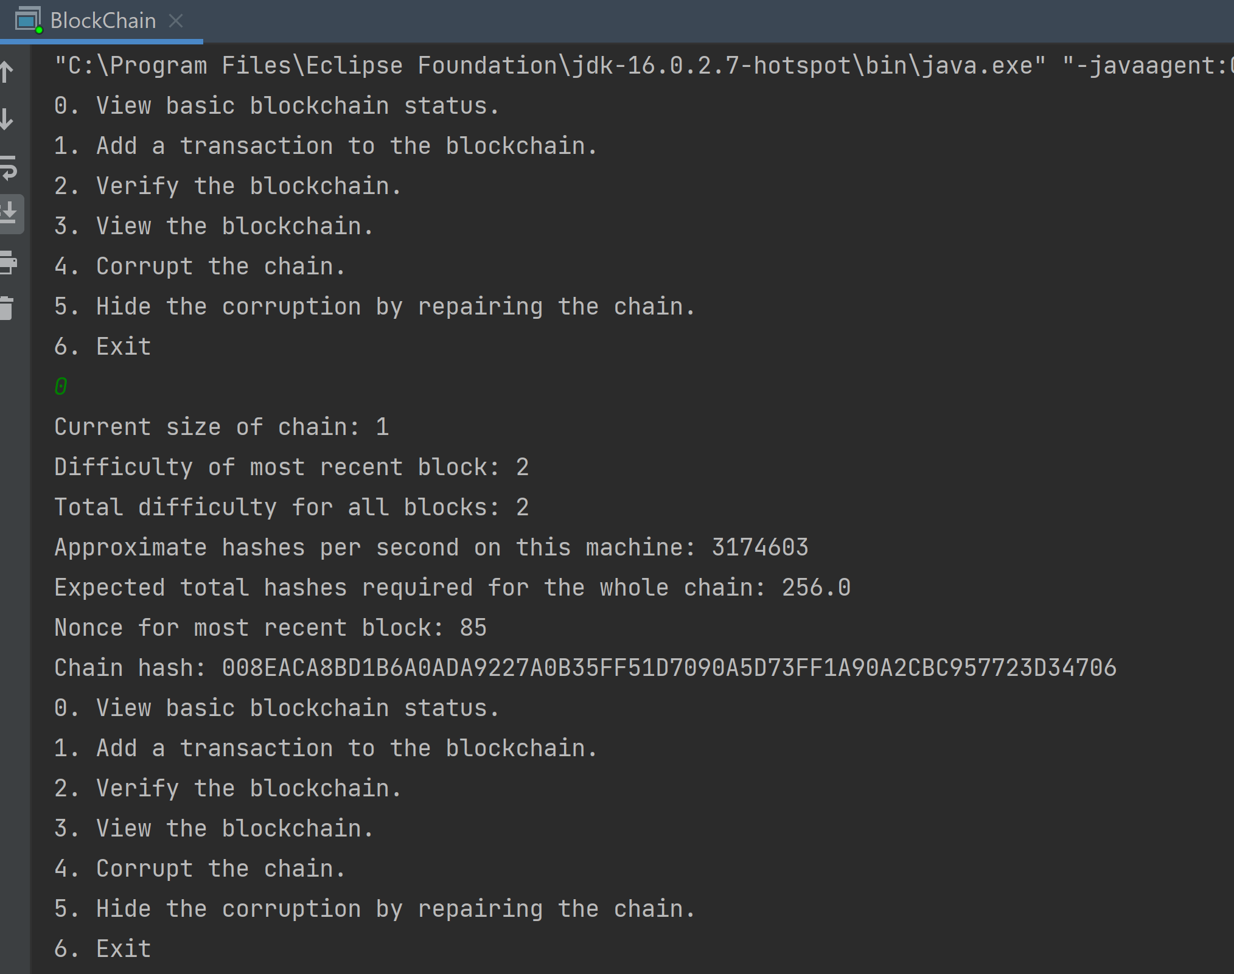

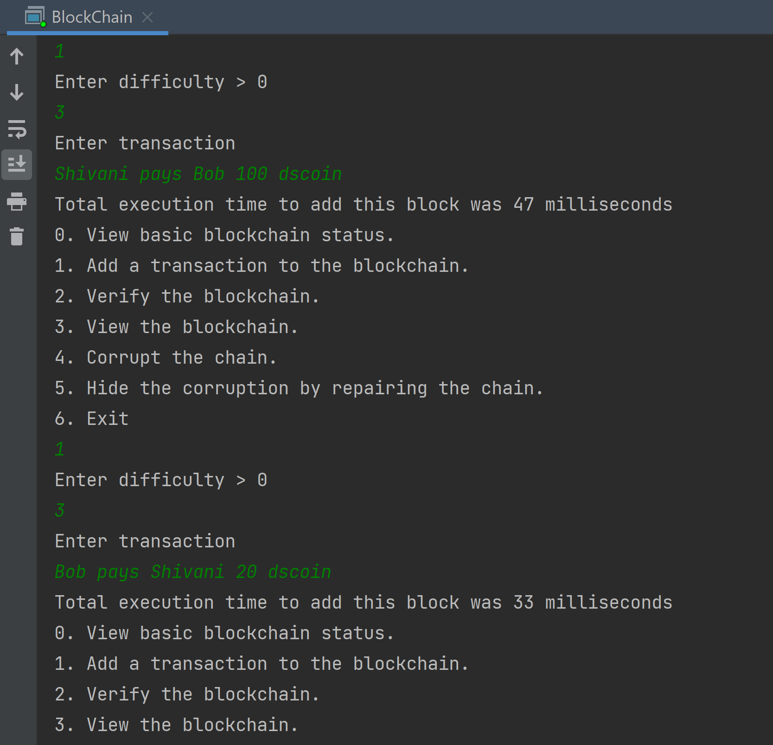

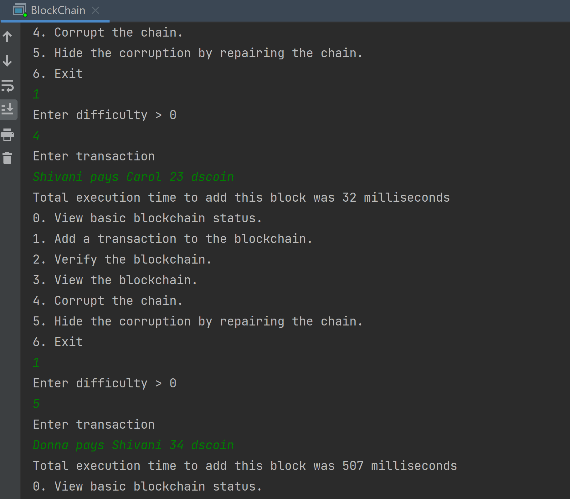

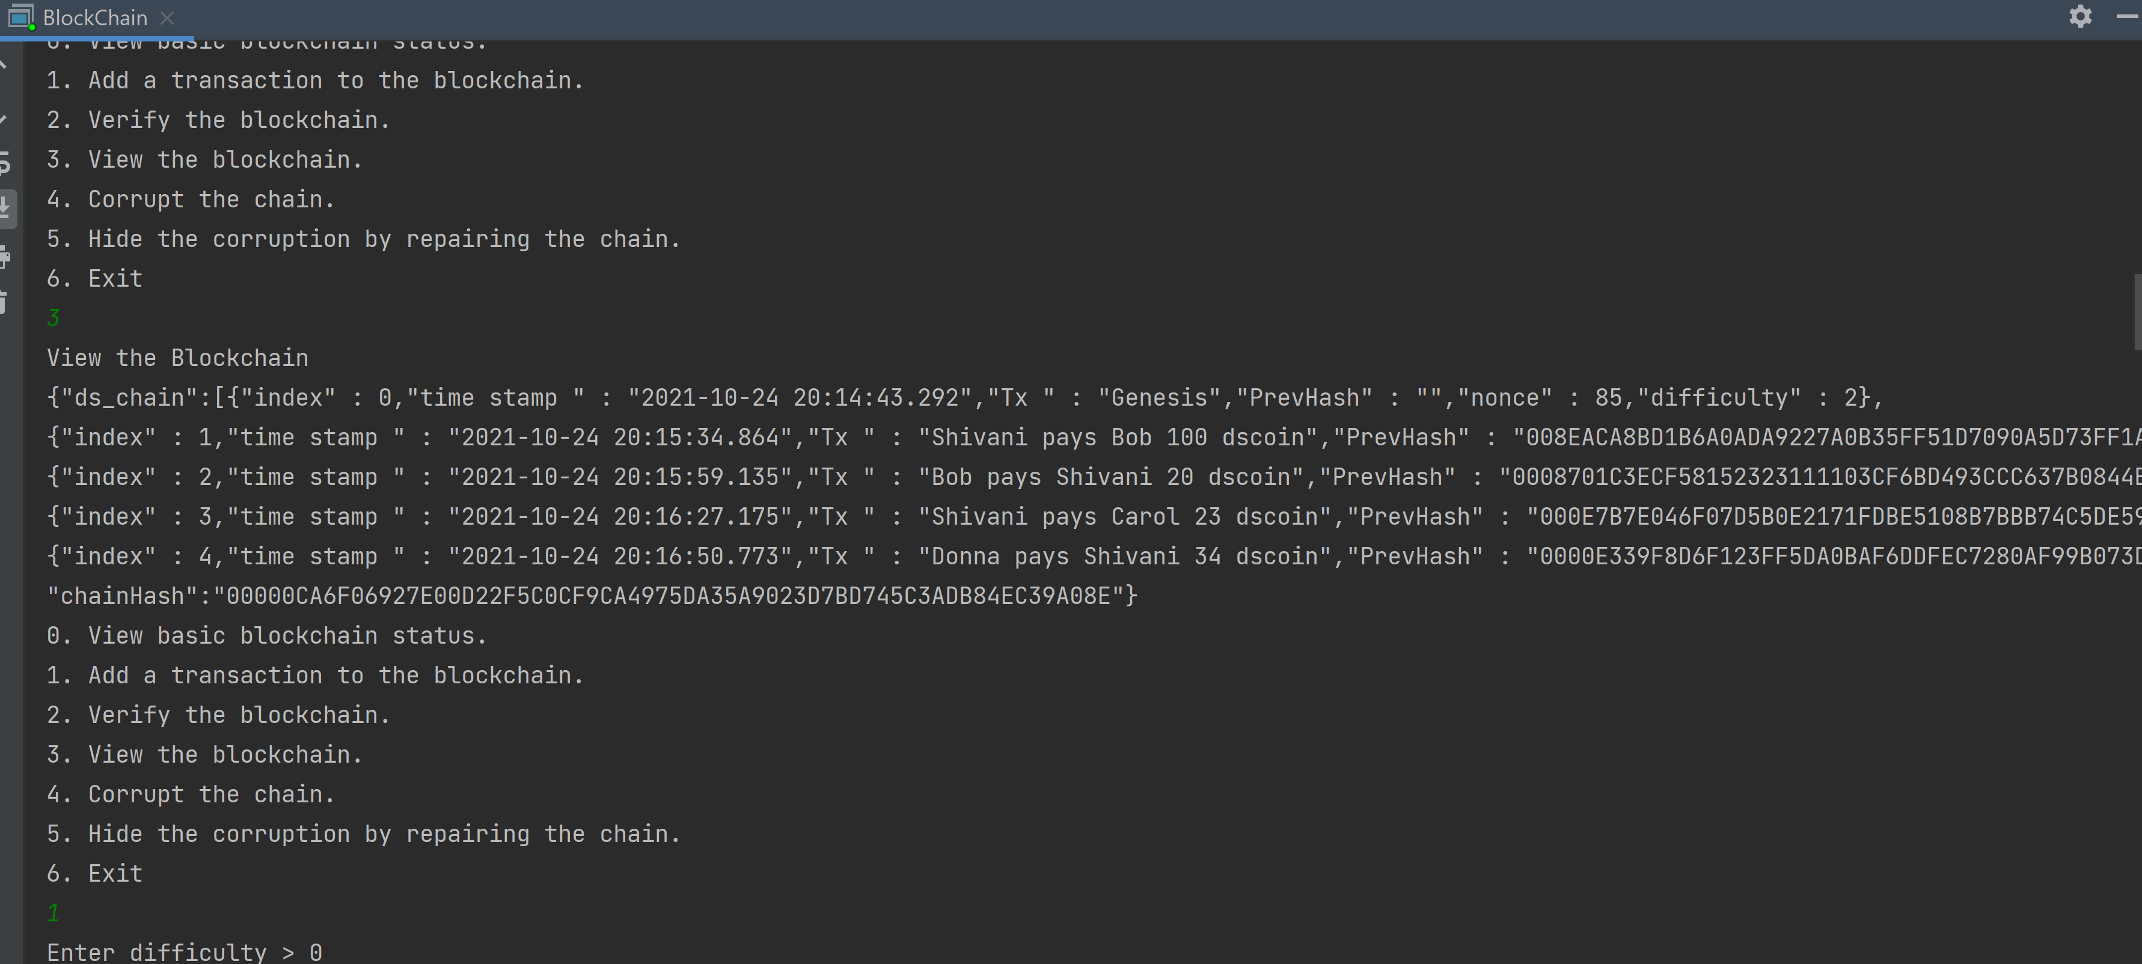

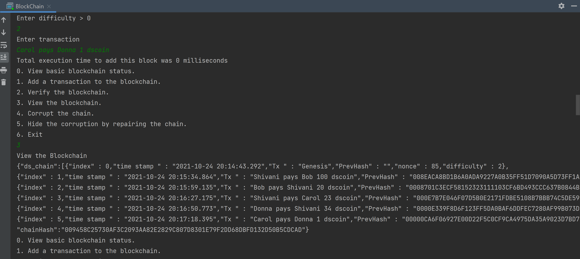

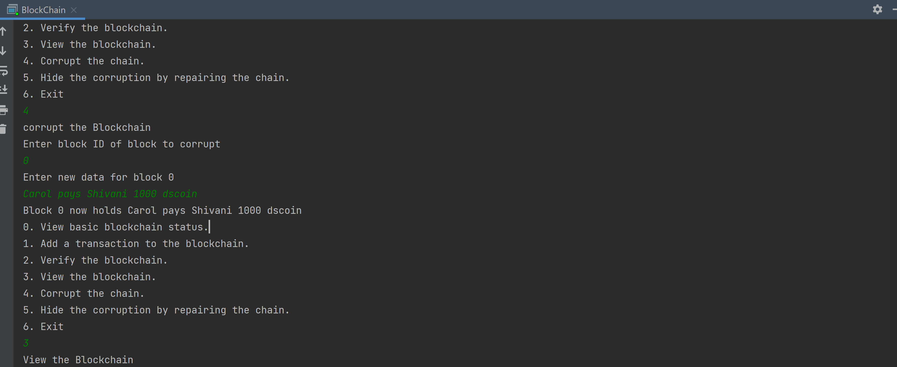

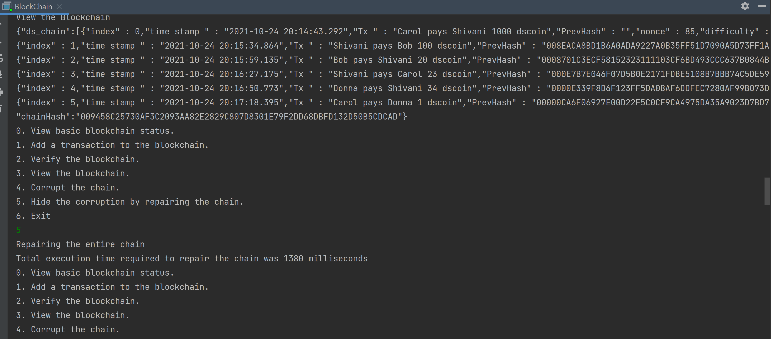

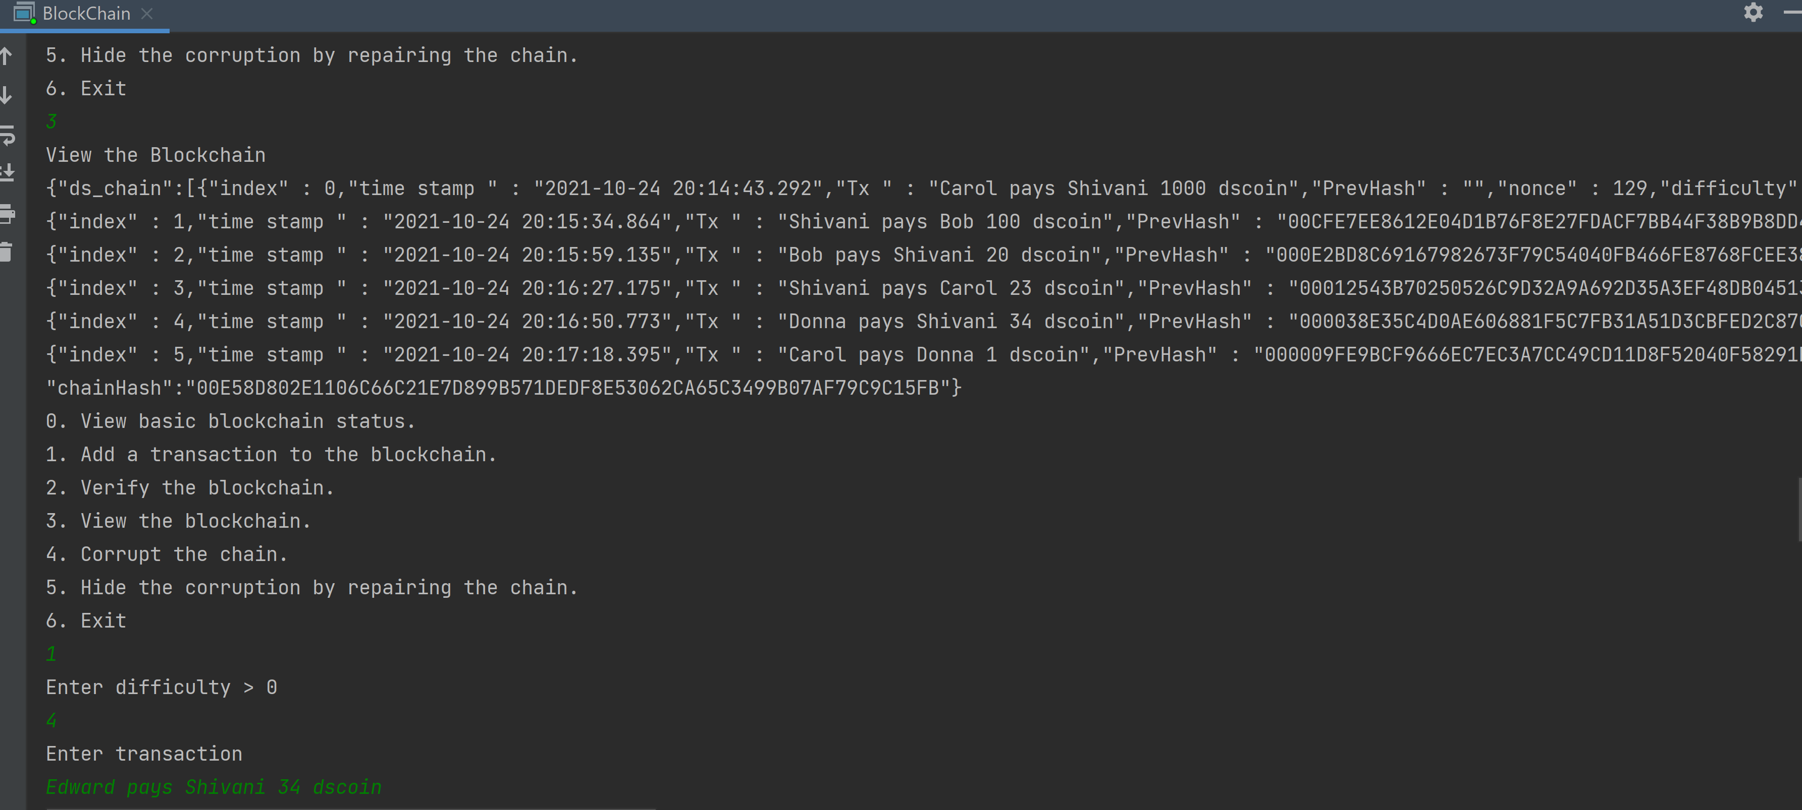

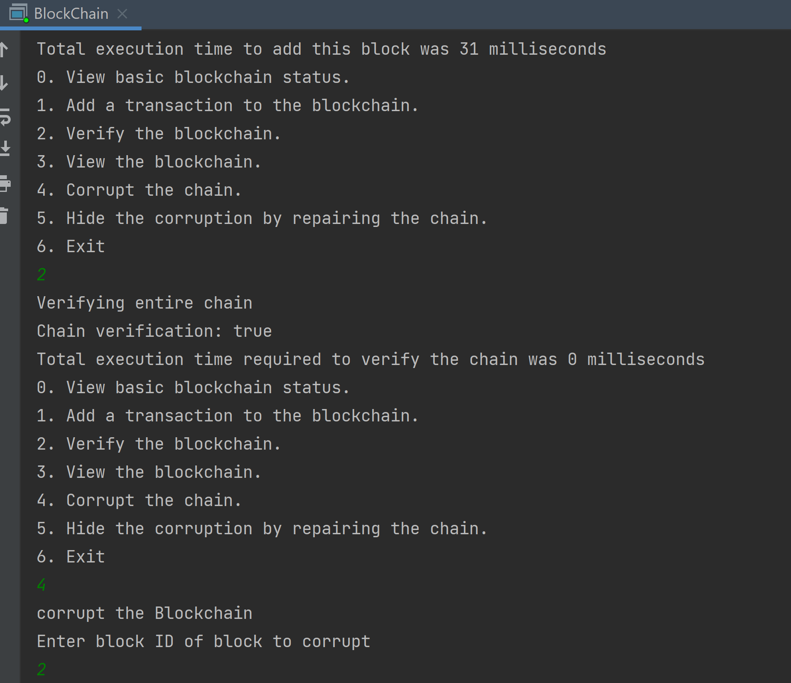

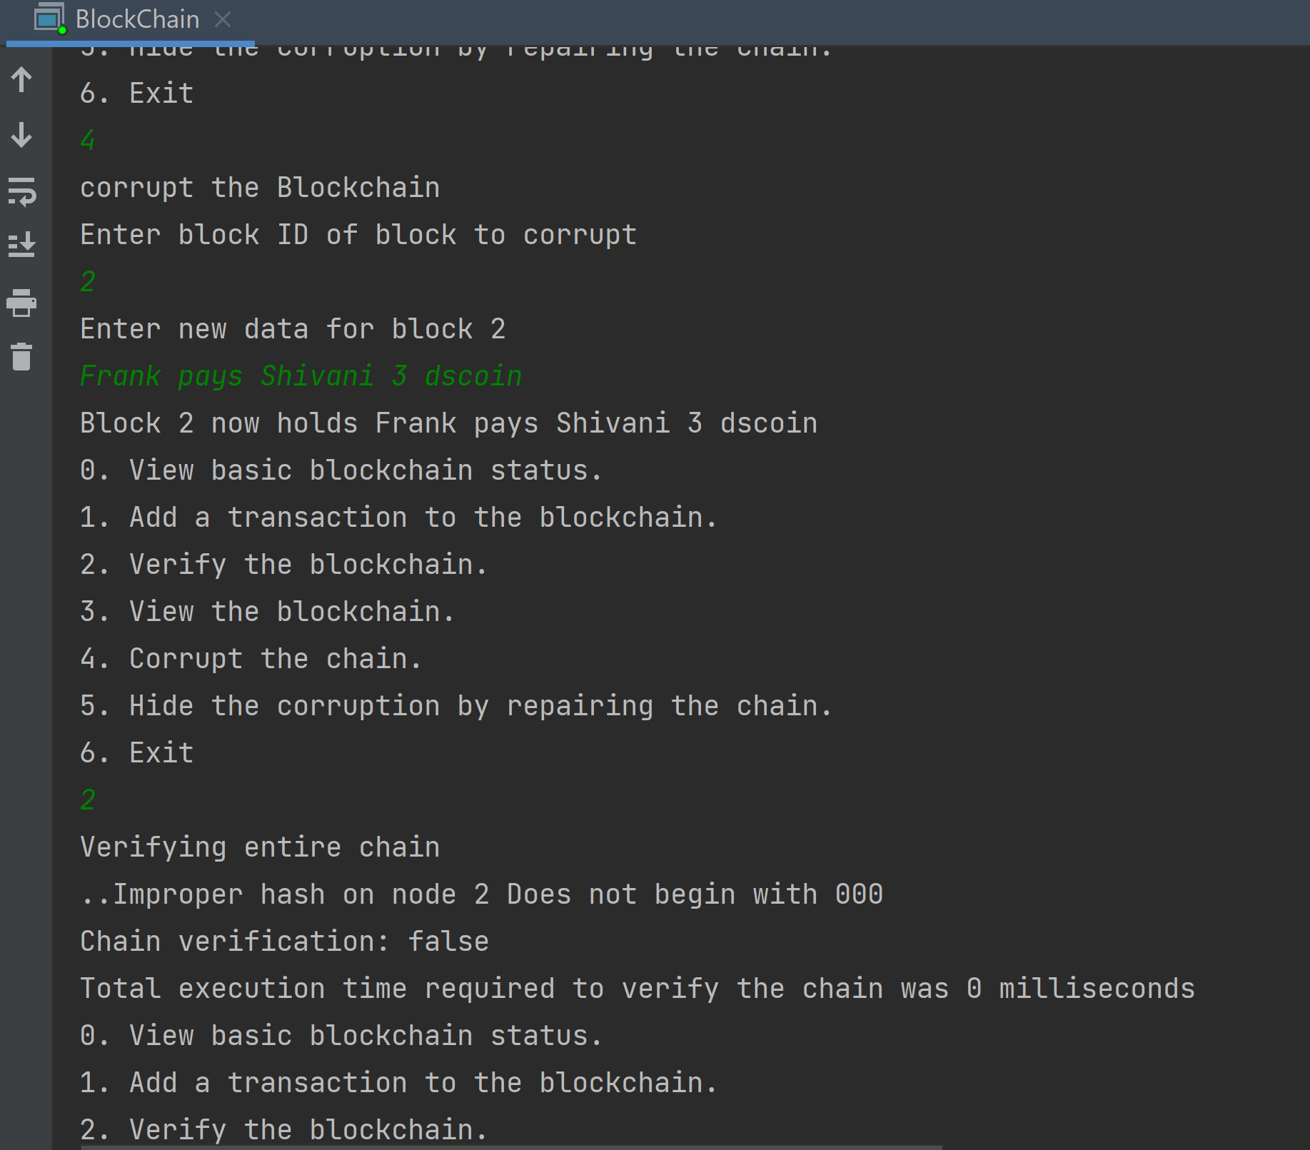

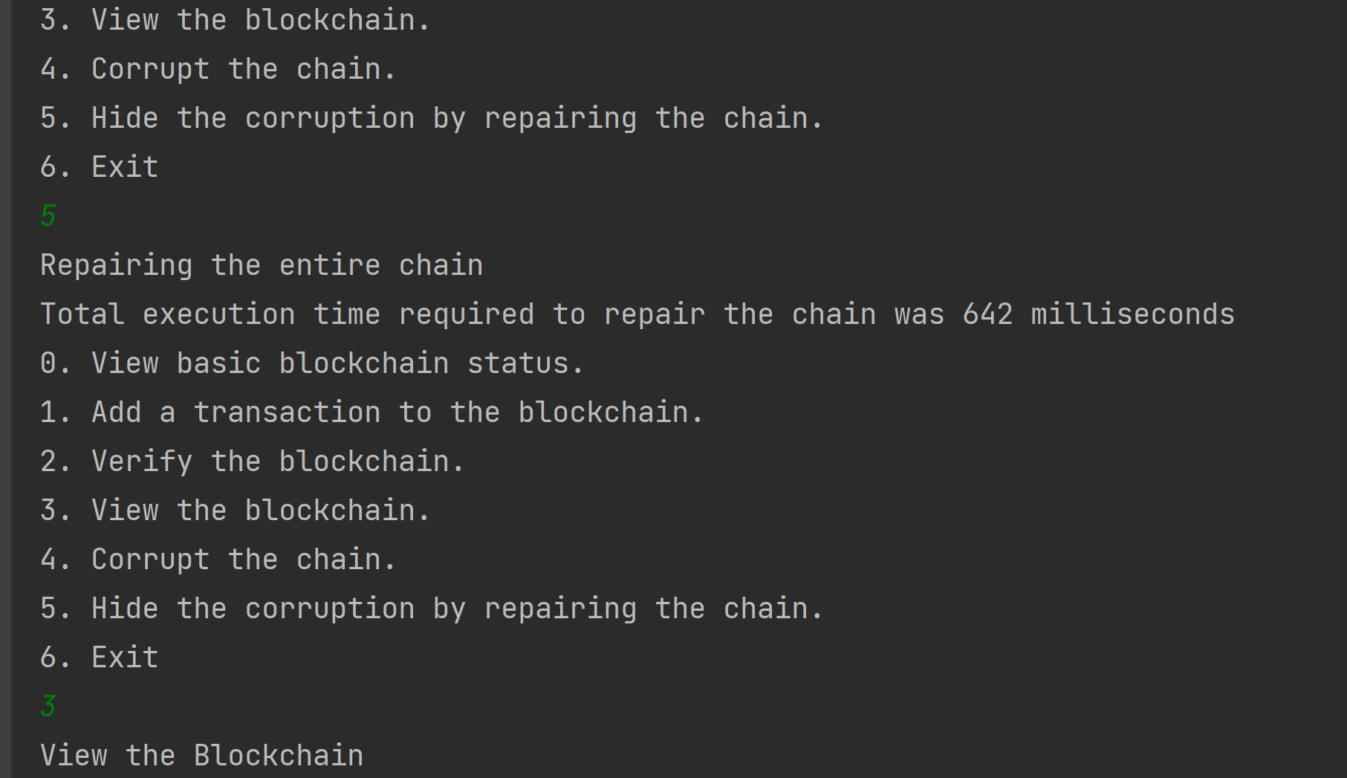

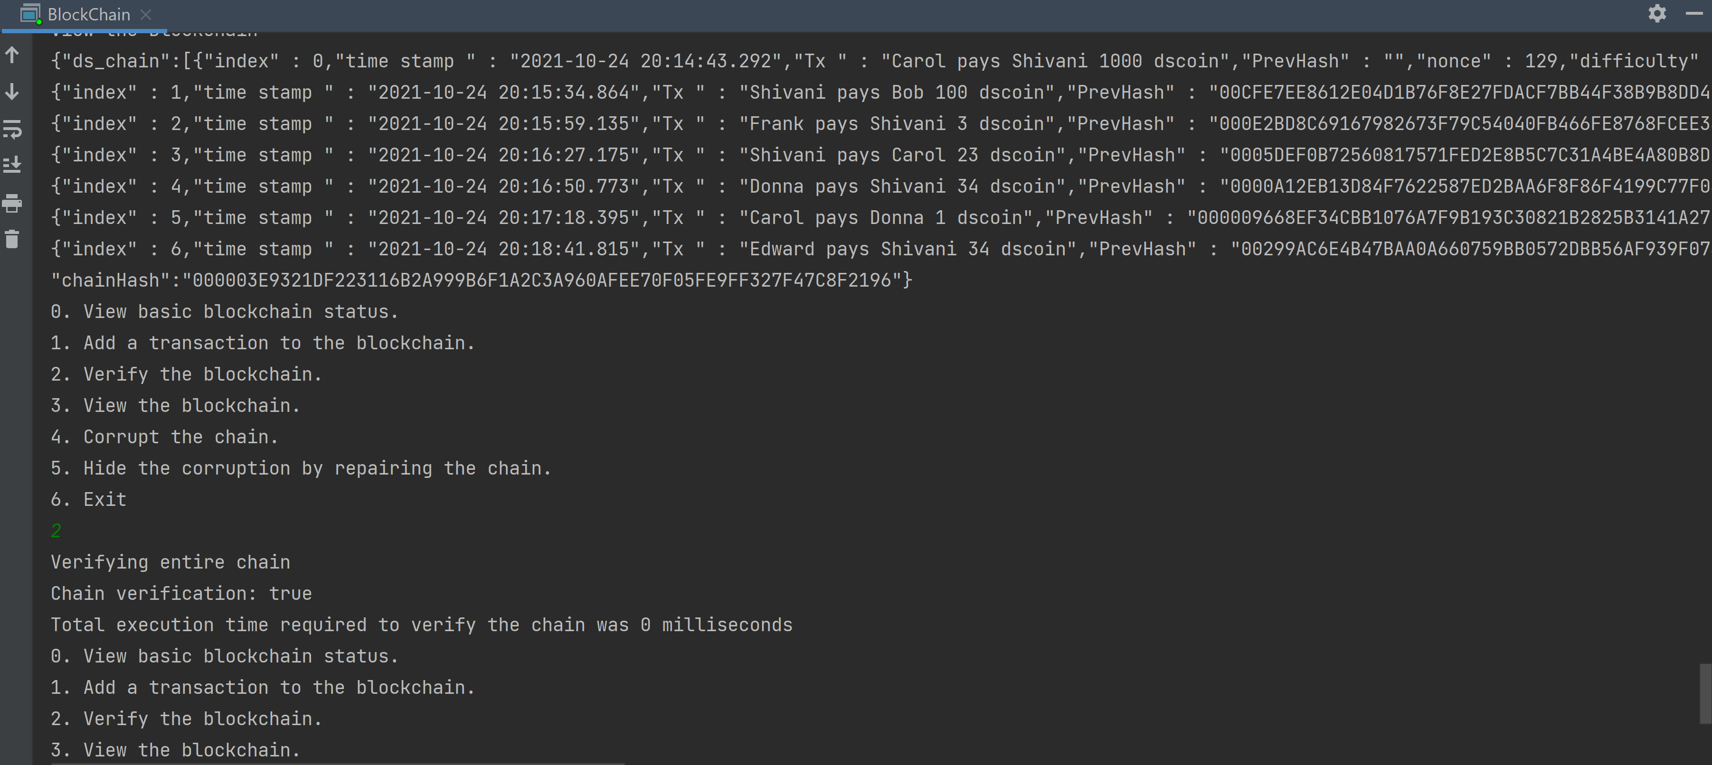

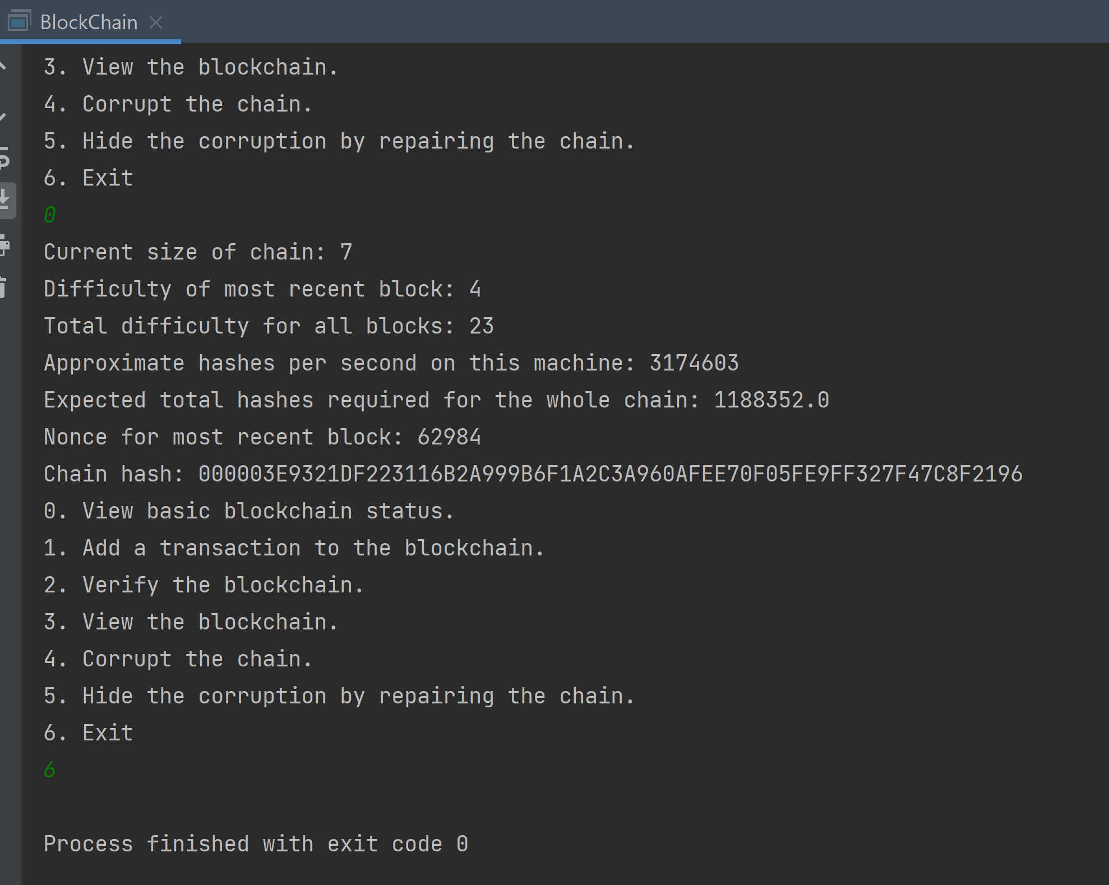

1. **Task 0 Block.java**

/*  
 * @author: Shivani Poovaiah Ajjikutira  
 * Last Modified: 24th October 2021  
 *  
 * Explanation and code taken from JavaDoc -  
 * https://www.andrew.cmu.edu/course/95-702/examples/javadoc/blockchaintask0/Block.html#getNonce()  
 * This class represents a simple Block.  
 * Each Block object has an index - the position of the block on the chain.  
 * The first block (the so-called Genesis block) has an index of 0.  
 * Each block has a timestamp - a Java Timestamp object, it holds the time of the block's creation.  
 * Each block has a field named data - a String holding the block's single transaction details.  
 * Each block has a String field named previousHash - the SHA256 hash of a block's parent.  
 * This is also called a hash pointer.  
 * Each block holds a nonce - a BigInteger value determined by a proof of work routine.  
 * This has to be found by the proof of work logic. It has to be found so that this block has a  
 * hash of the proper difficulty. The difficulty is specified by a small integer representing the  
 * minimum number of leading hex zeroes the hash must have.  
 * Each block has a field named difficulty - it is an int that specifies the minimum number of left  
 * most hex digits needed by a proper hash. The hash is represented in hexadecimal.  
 * If, for example, the difficulty is 3, the hash must have at least three leading hex 0's  
 * (or,1 and 1/2 bytes). Each hex digit represents 4 bits.  
 * */  
  
import java.math.BigInteger;  
import java.nio.charset.StandardCharsets;  
import java.security.MessageDigest;  
import java.security.NoSuchAlgorithmException;  
import java.sql.Timestamp;  
  
public class Block {  
 private int index;  
 private Timestamp timestamp;  
 private String data;  
 private int difficulty;  
 private BigInteger nonce;  
 private String previousHash;  
  
 /* constructor:  
 index - This is the position within the chain. Genesis is at 0.  
 timestamp - This is the time this block was added.  
 data - This is the transaction to be included on the blockchain.  
 difficulty - This is the number of leftmost nibbles that need to be 0.  
 nonce - The nonce is a number that has been found to cause the hash of this block to have the  
 correct number of leading hexadecimal zeroes.  
 */  
 Block (int index, Timestamp timestamp, String data, int difficulty){  
 this.index=index;  
 this.timestamp = timestamp;  
 this.data= data;  
 this.difficulty=difficulty;  
 this.nonce = new BigInteger("0");  
 }  
  
 public static void main (String[] args) {}  
  
 // This method computes a hash of the concatenation of the index,  
 // timestamp, data, previousHash, nonce, and difficulty.  
 public String calculateHashes(){  
 String block = index+String.*valueOf*(timestamp)+data+previousHash+nonce+difficulty;  
 byte[] bytesOfBlock = block.getBytes(StandardCharsets.*UTF_8*);  
 try {  
 MessageDigest md = MessageDigest.*getInstance*("SHA-256");  
 byte[] hashedOutput = md.digest(bytesOfBlock);  
 return *bytesToHex*(hashedOutput);  
 } catch (NoSuchAlgorithmException e) {  
 e.printStackTrace();  
 }  
 return block;  
 }  
  
 // Code from https://stackoverflow.com/questions/9655181/how-to-convert-a-byte-array-to-a-hex-string-in-java  
 private static final char[] *HEX_ARRAY* = "0123456789ABCDEF".toCharArray();  
 public static String bytesToHex(byte[] bytes) {  
 char[] hexChars = new char[bytes.length * 2];  
 for (int j = 0; j < bytes.length; j++) {  
 int v = bytes[j] & 0xFF;  
 hexChars[j * 2] = *HEX_ARRAY*[v >>> 4];  
 hexChars[j * 2 + 1] = *HEX_ARRAY*[v & 0x0F];  
 }  
 return new String(hexChars);  
 }  
  
 // getter for nonce  
 public BigInteger getNonce() {  
 return this.nonce;  
 }  
  
 // setter for nonce  
 public void setNonce(BigInteger nonce) {  
 this.nonce=nonce;  
 }  
  
 // The proof of work methods finds a good hash, i.e, the number of zeroes in the  
 // start of hash must be equal to difficulty of the block  
 public String proofOfWork() {  
 String hashReturned = "";  
 boolean proofOfWorkPass = false;  
 while(!proofOfWorkPass) {  
 hashReturned = calculateHashes();  
 char[] charsHash = hashReturned.toCharArray();  
 int difficulty = getDifficulty();  
 int numberOfZero = 0;  
 // count zeroes  
 for (int i = 0; i < difficulty; i++) {  
 if (charsHash[i] == '0') {  
 numberOfZero++;  
 }  
 }  
 if (numberOfZero == difficulty) proofOfWorkPass = true;  
 else setNonce(getNonce().add(BigInteger.*valueOf*(1)));  
 }  
 return hashReturned;  
 }  
  
 // getter for difficulty  
 public int getDifficulty() {  
 return this.difficulty;  
 }  
  
 // setter for difficulty  
 public void setDifficulty (int difficulty) {  
 this.difficulty = difficulty;  
 }  
  
 // toString method of individual block to form string in json format  
 public String toString() {  
 String blockString = String.*format*("{\"index\" : %d,\"time stamp \" : \"%s\",\"Tx \" : \"%s\",\"PrevHash\" : \"%s\",\"nonce\" : %d,\"difficulty\" : %d}",  
 index, timestamp, data, previousHash, nonce, difficulty);  
 return blockString;  
 }  
  
 // setter for previous hash  
 public void setPreviousHash(String previousHash) {  
 this.previousHash = previousHash;  
 }  
 // getter for previous hash  
 public String getPreviousHash() {  
 return this.previousHash;  
 }  
 // getter for index  
 public int getIndex() {  
 return this.index;  
 }  
  
 // setter for index  
 public void setIndex (int index) {  
 this.index =index;  
 }  
  
 // setter for timestamp  
 public void setTimestamp (Timestamp timestamp) {  
 this.timestamp= timestamp;  
 }  
  
 // getter for timestamp  
 public Timestamp getTimestamp() {  
 return this.timestamp;  
 }  
  
 // getter for data/transaction  
 public String getData() {  
 return this.data;  
 }  
  
 // setter for data/transaction  
 public void setData (String data) {  
 this.data = data;  
 }  
}

1. **Task 0 BlockChain.java**

/*  
 * @author: Shivani Poovaiah Ajjikutira  
 * Last Modified: 24th October 2021  
 *  
 * Explanation and code taken from JavaDoc -  
 * https://www.andrew.cmu.edu/course/95-702/examples/javadoc/blockchaintask0/BlockChain.html#isChainValid()  
 * This is the code for Blockchain. It will begin by creating a BlockChain object  
 * and then adding the Genesis block to the chain. The Genesis block will be created with an empty string  
 * as the previous hash and a difficulty of 2. On start up, this code will also establish the hashes per  
 * second instance member. All blocks added to the Blockchain will have a difficulty passed in to the  
 * program by the user at run time. All hashes will have the proper number of zero hex digits representing  
 * the most significant nibbles in the hash. A nibble is 4 bits. If the difficulty is specified as three,  
 * then all hashes will begin with 3 or more zero hex digits (or 3 nibbles, or 12 zero bits).  
 * It is menu-driven and will continuously provide the user with seven options:View basic blockchain  
 * status, add a transaction to the blockchain, verify the blockchain, view the blockchain, corrupt the  
 * chain, hide the corruption by repairing the chain, exit. Based on the user selection, certain  
 * operations are performed on the blockchain.  
 * */  
  
import java.nio.charset.StandardCharsets;  
import java.security.MessageDigest;  
import java.security.NoSuchAlgorithmException;  
import java.sql.Timestamp;  
import java.util.ArrayList;  
import java.util.Date;  
import java.util.Scanner;  
  
public class BlockChain {  
 // ArrayList to hold Blocks  
 private final ArrayList<Block> blocks;  
 // holds a SHA256 hash of the most recently added Block.  
 private String chainHash;  
 // Store hashes per second  
 private static int *hashesPerSecond*;  
 // store node having wrong hash  
 private int incorrectNode;  
  
 // constructor  
 BlockChain() {  
 // initialize blocks ArrayList, chainHash and hashesPerSecond  
 blocks= new ArrayList<>();  
 chainHash = "";  
 *hashesPerSecond*=0;  
 }  
  
 /*  
 * On startup the genesis block is created and added to the blockchain. The user is then  
 * prompted to select an option from the menu. Based on the user selection, operations are  
 * performed as results are displayed. Continue the process until the user selects 6,i.e,Exit  
 *  
 * Based on the experiments conducted the computation time increases as the difficulty associated  
 * with the block increases. For instance, for difficulty 2, addBlock() methods takes between  
 * 0-15 milliseconds approximately. For difficulty 5, addBlock() methods took 461 milliseconds  
 * approximately. For difficulty 6, addBlock() methods took 6000 milliseconds approximately.  
 * The repairChain() and isChainValid methods take approximately 0 milliseconds if all the blocks  
 * have correct data irrespective of the difficulty of the blocks. However, in the presence of a  
 * malicious block having corrupt data, repairChain() method takes longer time if there are blocks  
 * with higher difficulty. For instance, if malicious block has a difficulty of 2, the  
 * repairChain() method took 2775 milliseconds. But if malicious block has a difficulty of 6, the  
 * repairChain() method took 13221 milliseconds. isChainValid() method also takes longer time  
 * if malicious block has higher difficulty. For difficulty 2 of malicious block, isChainValid()  
 * method took close to 0 milliseconds and for difficulty 6, method took close to 362 milliseconds.  
 * */  
 public static void main (String[] args) {  
 BlockChain blockChain = new BlockChain();  
 Block genesisBlock = new Block(0, new Timestamp(new Date().getTime()), "Genesis", 2);  
 genesisBlock.setPreviousHash("");  
 blockChain.computeHashesPerSecond();  
 blockChain.addBlock(genesisBlock);  
 int userInput = -1;  
 while(userInput!=6) {  
 *displayMenu*();  
 Scanner getInput = new Scanner(System.*in*);  
 userInput = Integer.*parseInt*(getInput.nextLine());  
 switch (userInput) {  
 // display basic blockchain status  
 case 0 -> {  
 System.*out*.println("Current size of chain: " + blockChain.getChainSize());  
 System.*out*.println("Difficulty of most recent block: " + blockChain.getLatestBlock().getDifficulty());  
 System.*out*.println("Total difficulty for all blocks: " + blockChain.getTotalDifficulty());  
 System.*out*.println("Approximate hashes per second on this machine: " + blockChain.getHashesPerSecond());  
 System.*out*.println("Expected total hashes required for the whole chain: " + blockChain.getTotalExpectedHashes());  
 System.*out*.println("Nonce for most recent block: " + blockChain.getLatestBlock().getNonce());  
 System.*out*.println("Chain hash: " + blockChain.chainHash);  
 }  
 // fetch difficulty, transaction data from user, use this data to create a new block  
 // and add new block created to the blockchain. Calculate the time taken for this  
 // operation  
 case 1 -> {  
 System.*out*.println("Enter difficulty > 0");  
 int difficulty = Integer.*parseInt*(getInput.nextLine());  
 System.*out*.println("Enter transaction");  
 String transaction = getInput.nextLine();  
 long startTime = System.*currentTimeMillis*();  
 blockChain.addBlock(new Block(blockChain.getLatestBlock().getIndex() + 1,  
 new Timestamp(new Date().getTime()), transaction, difficulty));  
 long endTime = System.*currentTimeMillis*();  
 System.*out*.println("Total execution time to add this block was " + (endTime - startTime) + " milliseconds");  
 }  
 // check if the chain is correct or not and display to user.  
 // If chain is incorrect, display the incorrect node information  
 // to the user along with the total execution time for the checking process  
 case 2 -> {  
 System.*out*.println("Verifying entire chain");  
 long startTime = System.*currentTimeMillis*();  
 boolean chainVerified = blockChain.isChainValid();  
 long endTime = System.*currentTimeMillis*();  
 if (!chainVerified) {  
 int difficulty = blockChain.getBlock(blockChain.incorrectNode).getDifficulty();  
 System.*out*.printf("..Improper hash on node %d Does not begin with %s\n", blockChain.incorrectNode, "0".repeat(Math.*max*(0, difficulty)));  
 }  
 System.*out*.println("Chain verification: " + chainVerified);  
 System.*out*.println("Total execution time required to verify the chain was " + (endTime - startTime) + " milliseconds");  
 }  
 // display the blockchain to the user in json format  
 case 3 -> System.*out*.println(blockChain);  
 // fetch id, and transaction from the user and corrupt the blockchain with  
 // this data  
 case 4 -> {  
 System.*out*.println("corrupt the Blockchain\n" +  
 "Enter block ID of block to corrupt");  
 int blockId = Integer.*parseInt*(getInput.nextLine());  
 System.*out*.println("Enter new data for block " + blockId);  
 String blockTransaction = getInput.nextLine();  
 blockChain.getBlock(blockId).setData(blockTransaction);  
 System.*out*.printf("Block %d now holds %s\n", blockId, blockTransaction);  
 }  
 // repair the blockchain and display the total execution time for the repairing process  
 case 5 -> {  
 System.*out*.println("Repairing the entire chain");  
 long startTime = System.*currentTimeMillis*();  
 blockChain.repairChain();  
 long endTime = System.*currentTimeMillis*();  
 System.*out*.printf("Total execution time required to repair the chain was %d milliseconds\n", endTime - startTime);  
 }  
 }  
 }  
 }  
  
 // check the proofOfWork for each block and add it to the blockchain, update  
 // chain hash with the latest added block's proofOfWork  
 public void addBlock (Block newBlock) {  
 if(blocks.size()!=0) newBlock.setPreviousHash(getBlock(blocks.size()-1).proofOfWork());  
 blocks.add(newBlock);  
 chainHash = newBlock.proofOfWork();  
 }  
  
 // getter for timestamp  
 public Timestamp getTime() {  
 return new Timestamp(new Date().getTime());  
 }  
  
 // getter for latest block  
 public Block getLatestBlock() {  
 return getBlock(blocks.size()-1);  
 }  
  
 // getter for chain size  
 public int getChainSize() {  
 return blocks.size();  
 }  
  
 /*  
 * This method computes exactly 1 million hashes and times how long that process takes.  
 * So, hashes per second is approximated as (1 million / number of seconds). It is run on start  
 * up and sets the instance variable hashesPerSecond. It uses a simple string -  
 * "00000000" to hash.*/  
 public void computeHashesPerSecond() {  
 String sampleString = "00000000";  
 long startTime = getTime().getTime();  
 byte[] bytesOfHash = sampleString.getBytes(StandardCharsets.*UTF_8*);  
 for(int i=0; i<1000000;i++) {  
 try {  
 // Use SHA-256 for hashing  
 MessageDigest md = MessageDigest.*getInstance*("SHA-256");  
 md.digest(bytesOfHash);  
 } catch (NoSuchAlgorithmException e) {  
 e.printStackTrace();  
 }  
 }  
 long endTime = getTime().getTime();  
 BlockChain.*hashesPerSecond* = (int) (1000000*1000/ (double) (endTime - startTime));  
 }  
  
 public int getHashesPerSecond() {  
 return *hashesPerSecond*;  
 }  
  
 // creates string in json format for entire blockchain using toString method of  
 // individual blocks  
 public String toString() {  
 System.*out*.println("View the Blockchain");  
 StringBuilder jsonString= new StringBuilder("{\"ds_chain\":[");  
 for(int i=0; i<blocks.size();i++) {  
 Block block = getBlock(i);  
 String blockString;  
 if(i!= blocks.size()-1) {  
 blockString = block+",\n";  
 } else {  
 blockString = String.*format*("%s],\n\"chainHash\":\"%s\"}",block,chainHash);  
 }  
 jsonString.append(blockString);  
 }  
 return jsonString.toString();  
 }  
  
 // getter for block at index i  
 public Block getBlock (int i) {  
 return blocks.get(i);  
 }  
  
 // compute and return the total difficulty of all blocks on the chain.  
 public int getTotalDifficulty() {  
 int totalDifficulty=0;  
 for(int i=0; i< blocks.size(); i++) {  
 totalDifficulty+=getBlock(i).getDifficulty();  
 }  
 return totalDifficulty;  
 }  
  
 // Compute and return the expected number of hashes required for the entire chain.  
 public double getTotalExpectedHashes() {  
 double totalExpectedHashes = 0;  
 for(int i=0; i<blocks.size();i++) {  
 totalExpectedHashes += Math.*pow*((16),getBlock(i).getDifficulty());  
 }  
 return totalExpectedHashes;  
 }  
  
 /*  
 * If the chain only contains one block, the genesis block at position 0, this method computes  
 * the hash of the block and checks that the hash has the requisite number of leftmost 0's  
 * (proof of work) as specified in the difficulty field. It also checks that the chain hash  
 * is equal to this computed hash. If either check fails, return false. Otherwise, return true.  
 * If the chain has more blocks than one, begin checking all blocks using chainValidation  
 * method. If chainValidation method returns a non-negative number continue checking the  
 * blocks in the blockchain. When chainValidation method returns -1, then it means the  
 * chain validation fails. */  
 public boolean isChainValid() {  
 if(blocks.size()==1) {  
 Block genesis = getBlock(0);  
 String genesisHash = genesis.proofOfWork();  
 int numberOfZero = 0;  
 int difficulty = genesis.getDifficulty();  
 char[] charsHash = genesisHash.toCharArray();  
 for (int i = 0; i < difficulty; i++) {  
 if (charsHash[i] == '0') numberOfZero++;  
 }  
 return chainHash.equals(genesisHash) && numberOfZero == difficulty;  
 } else {  
 for(int i=0; i<blocks.size();i++) {  
 // checks each node  
 int node = chainValidation(i);  
 if(node==-1) {  
 // setting index of incorrect node with wrong hash value  
 incorrectNode=i-1;  
 return false;  
 }  
 }  
 return chainHash.equals(getLatestBlock().proofOfWork());  
 }  
 }  
  
 /*  
 * Check hash pointer of each Block and compare with proofOfWork of previous block.  
 * If they match and if the proof of work is correct, return block index. else  
 * return -1; */  
 public int chainValidation(int blockIndex) {  
 String prevBlockHash = blockIndex==0?  
 "":getBlock(blockIndex-1).proofOfWork();  
 String hashPointer = getBlock(blockIndex).getPreviousHash();  
 if(prevBlockHash.equals(hashPointer)) {  
 if(blockIndex!=0){  
 char[] charsHash = prevBlockHash.toCharArray();  
 int difficulty = getBlock(blockIndex-1).getDifficulty();  
 int numberOfZero = 0;  
 for (int i = 0; i < difficulty; i++) {  
 if (charsHash[i] == '0') numberOfZero++;  
 }  
 if (numberOfZero == difficulty) return blockIndex;  
 }  
 return blockIndex;  
 }  
 return -1;  
 }  
  
 // checks each block and recomputes proofOfWork for each block and  
 // assigns the correct hash pointer in the next block as well as the  
 // chain hash using the proofOfWork of the last added block.  
 public void repairChain() {  
 for(int i=0; i<getChainSize();i++) {  
 if(i==0) getBlock(i).setPreviousHash("");  
 String correctHash = getBlock(i).proofOfWork();  
 if(i+1 < getChainSize())getBlock(i+1).setPreviousHash(correctHash);  
 if(i==getChainSize()-1) chainHash=correctHash;  
 }  
 chainHash=getLatestBlock().proofOfWork();  
 }  
  
 // menu options to be displayed to user  
 private static void displayMenu() {  
 System.*out*.println("""  
 0. View basic blockchain status.  
 1. Add a transaction to the blockchain.  
 2. Verify the blockchain.  
 3. View the blockchain.  
 4. Corrupt the chain.  
 5. Hide the corruption by repairing the chain.  
 6. Exit""");  
 }  
  
}

1. **Task 1 Execution**

Important:

In order to parse JSON objects, GSON (version: gson-2.8.4.jar) library is added to the Maven project. Additionally, json-simple-1.1.1 jar is also added to the project to create JSON object. This jar file is added in the zip file. Please add this dependency to the Maven project as well before running the code in Task 1.

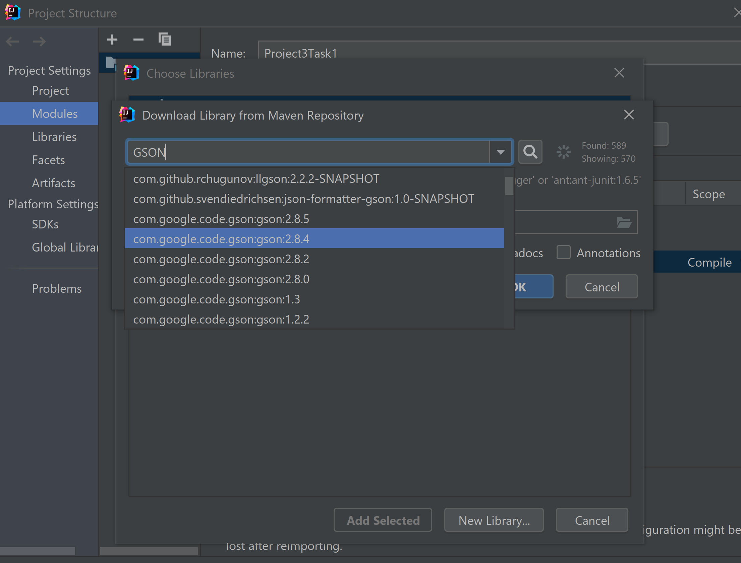

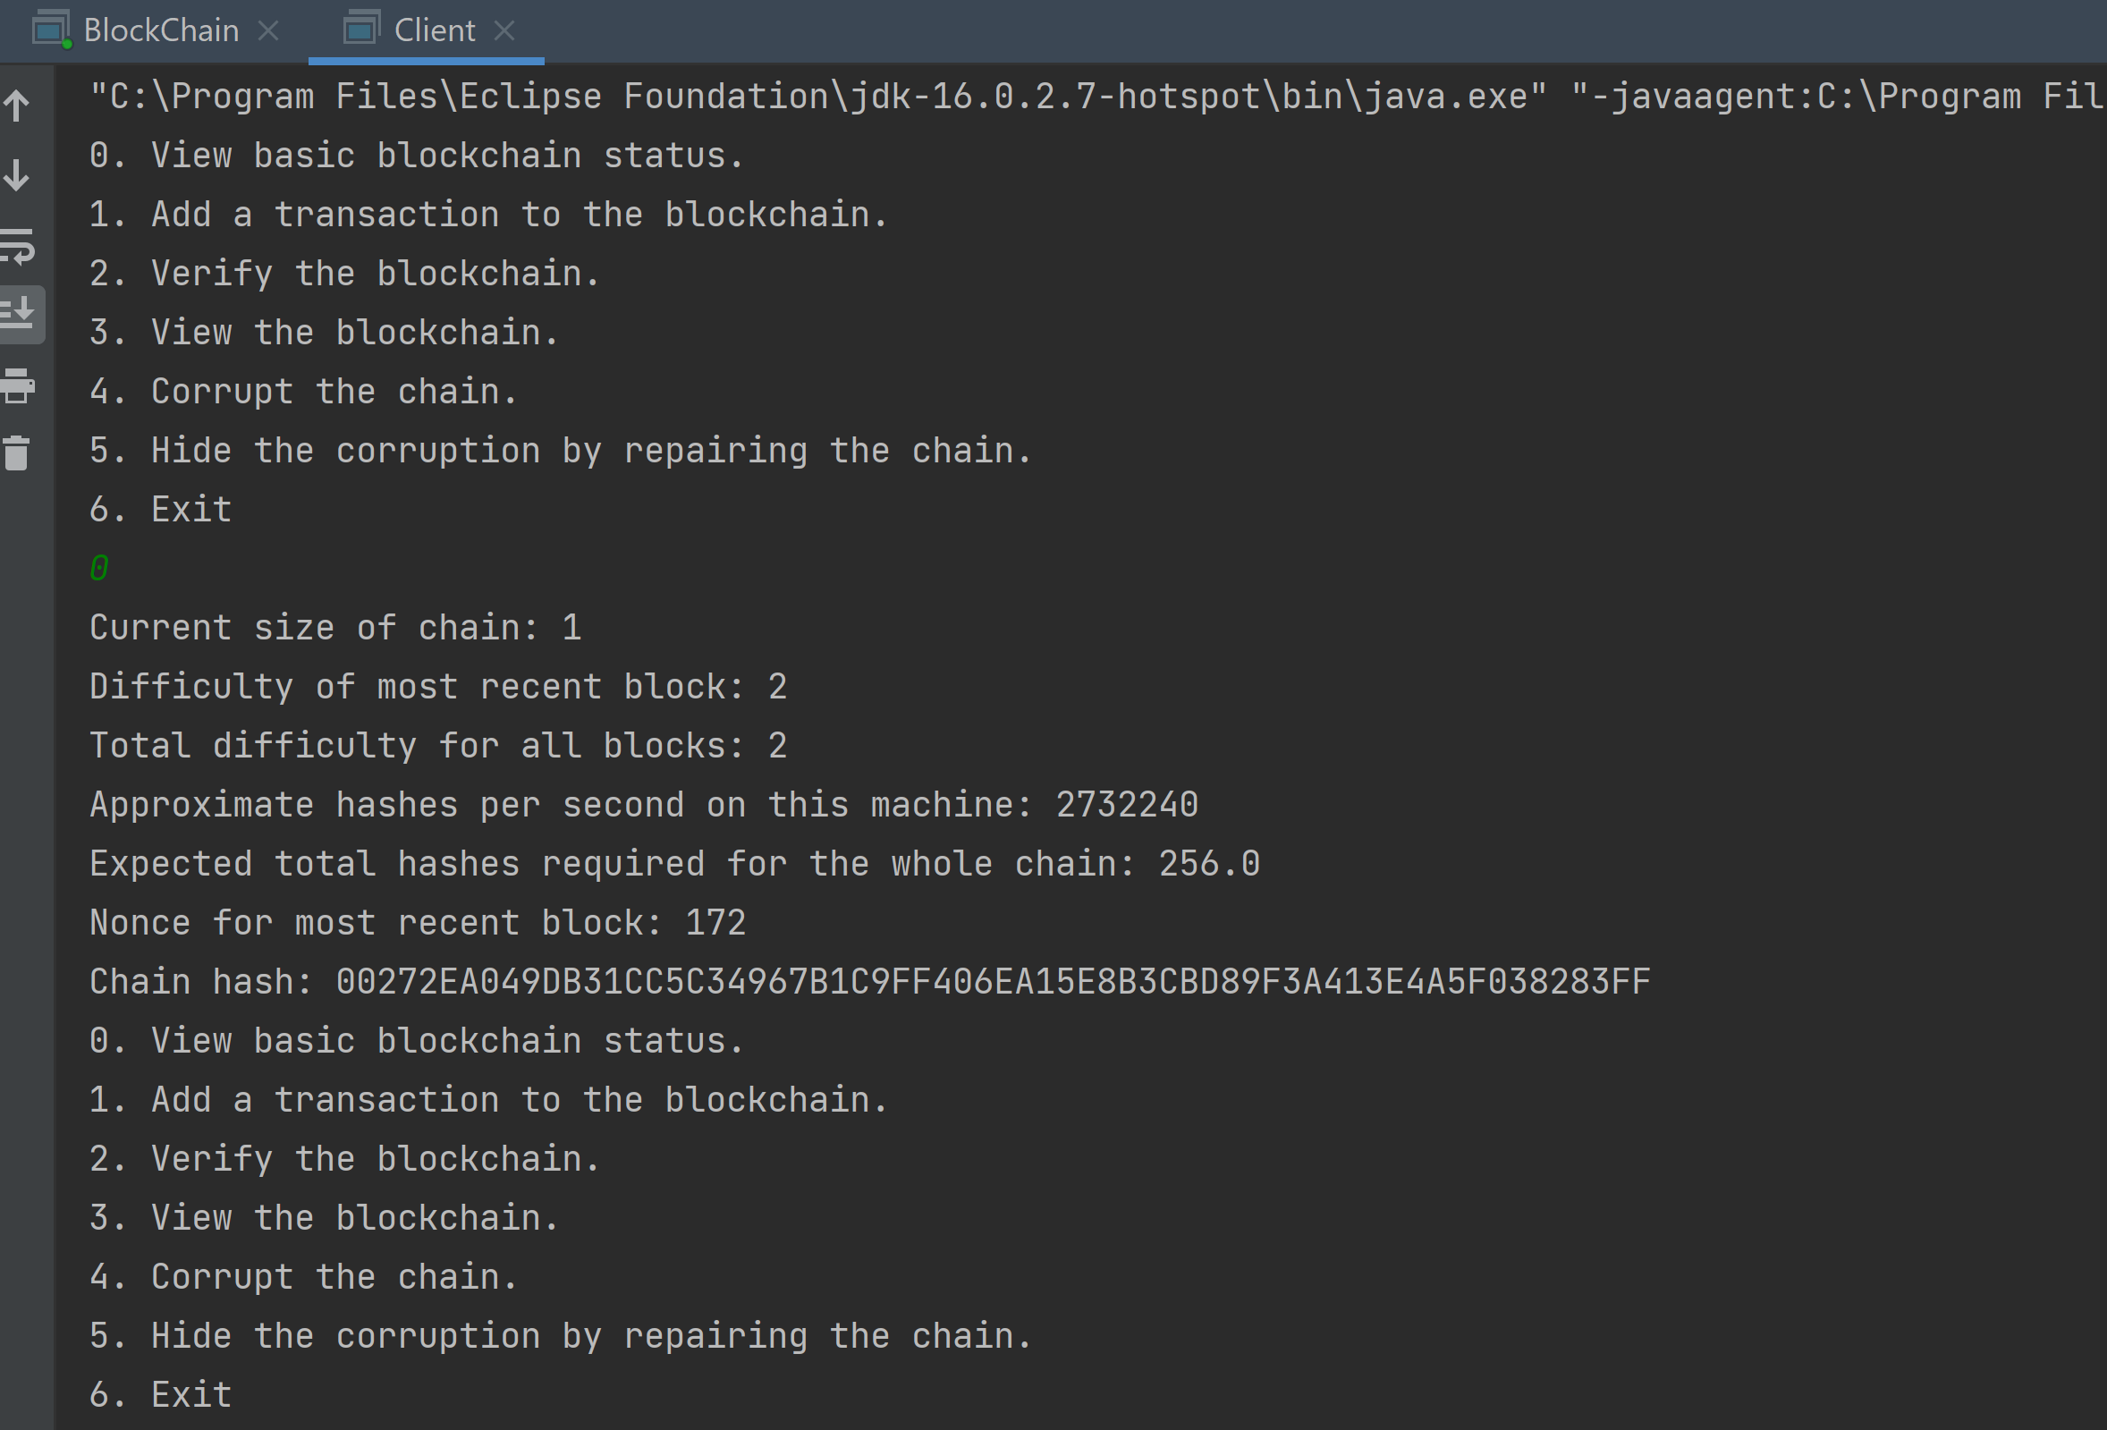

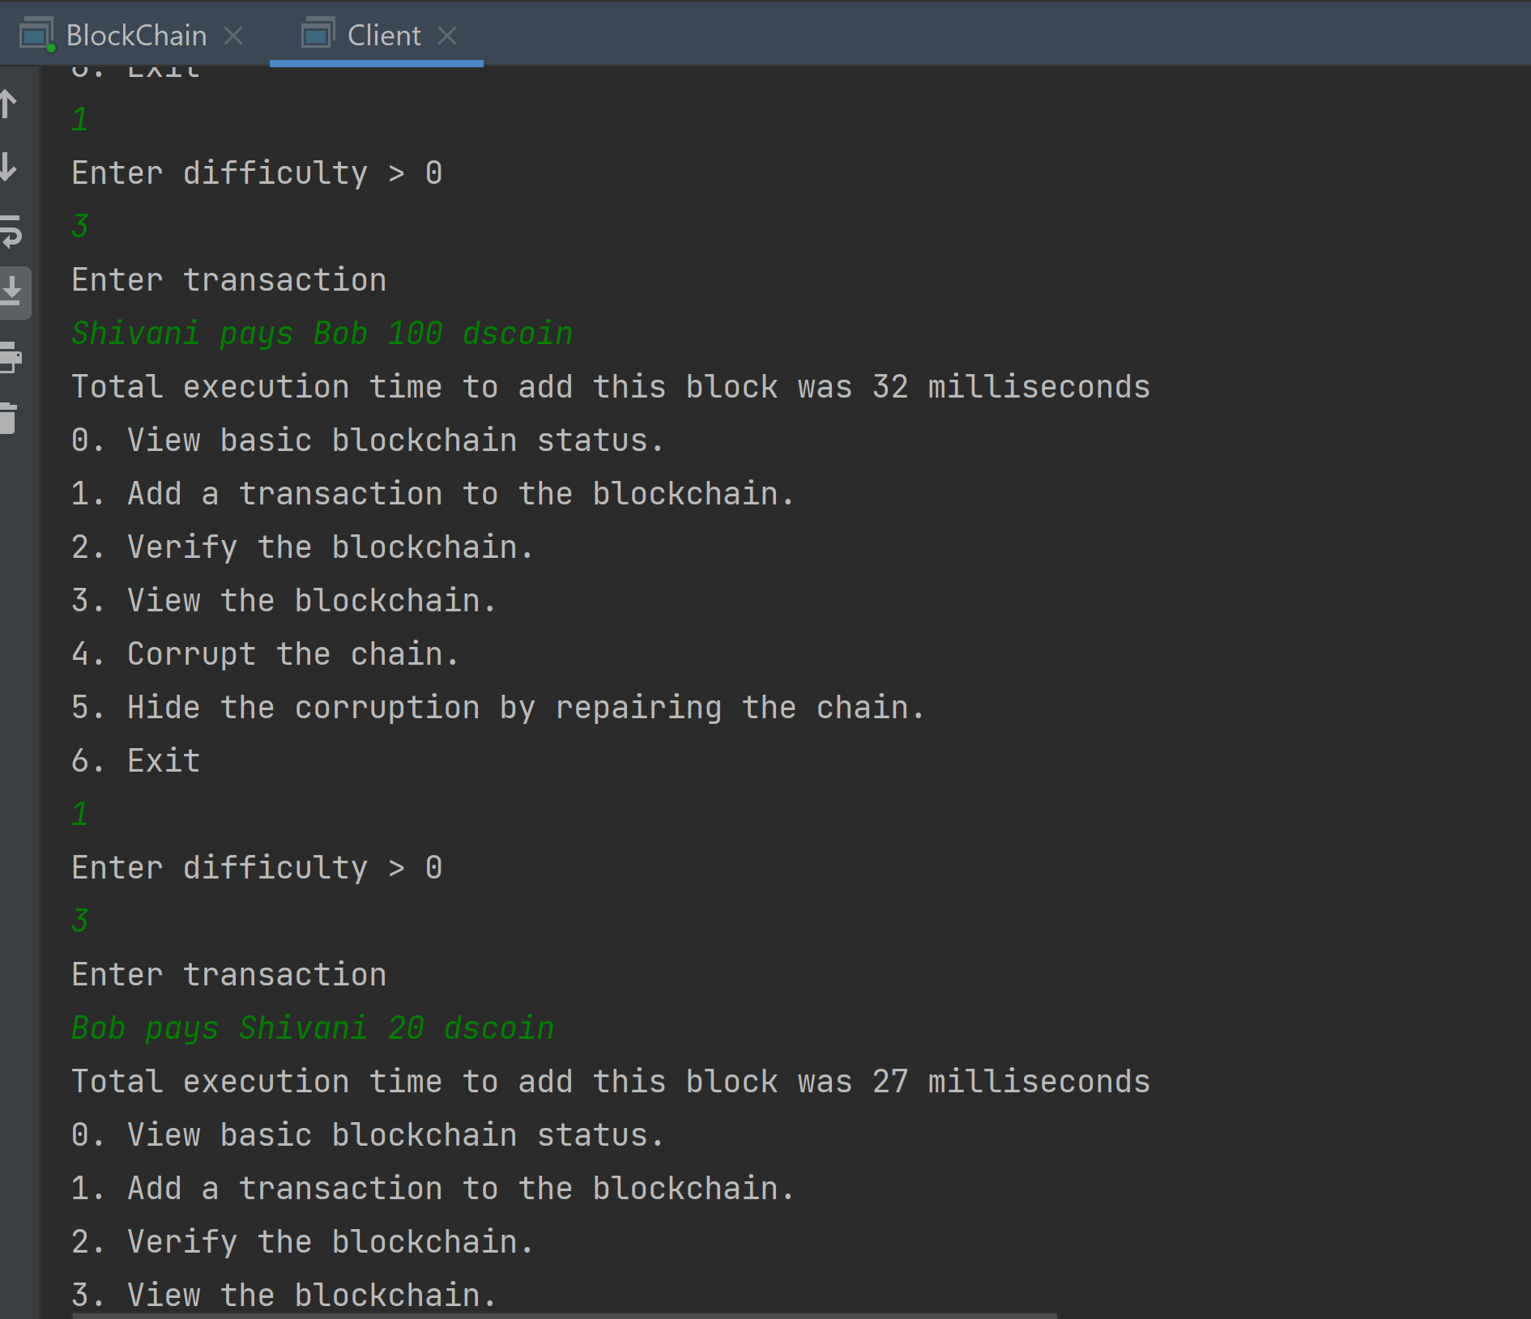

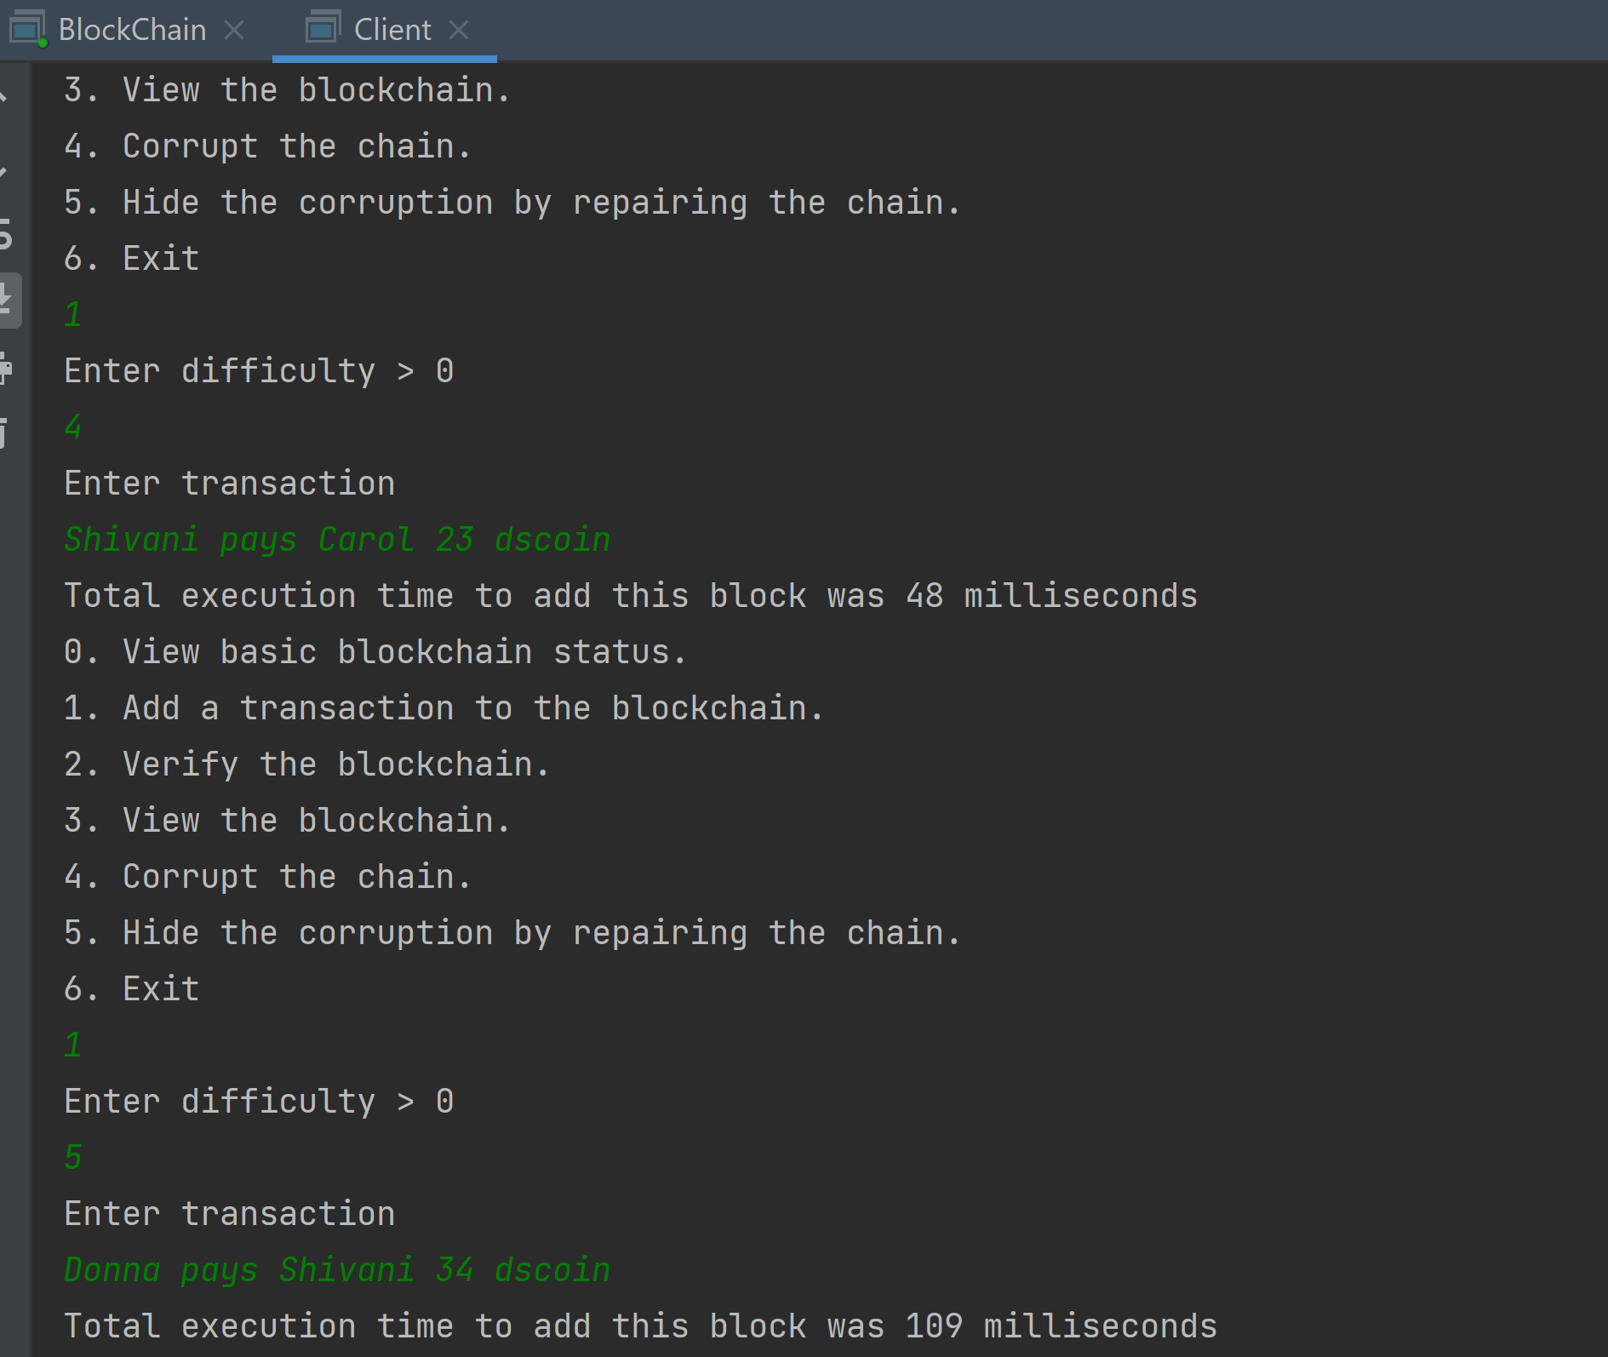

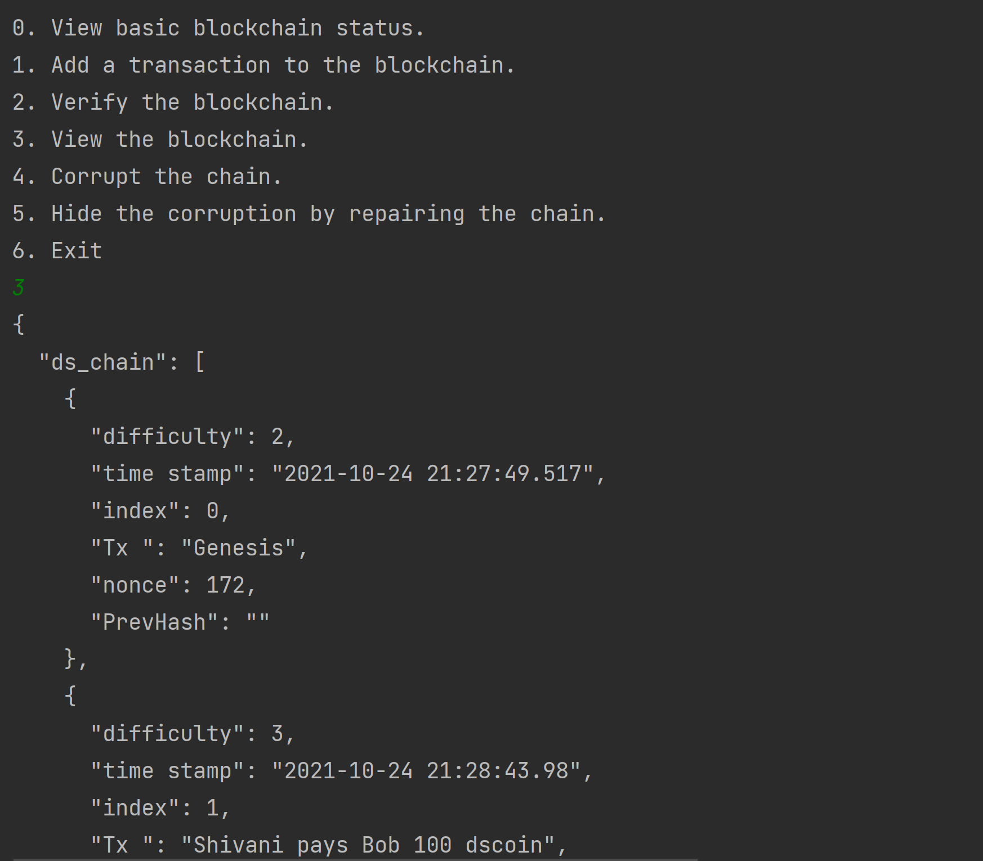

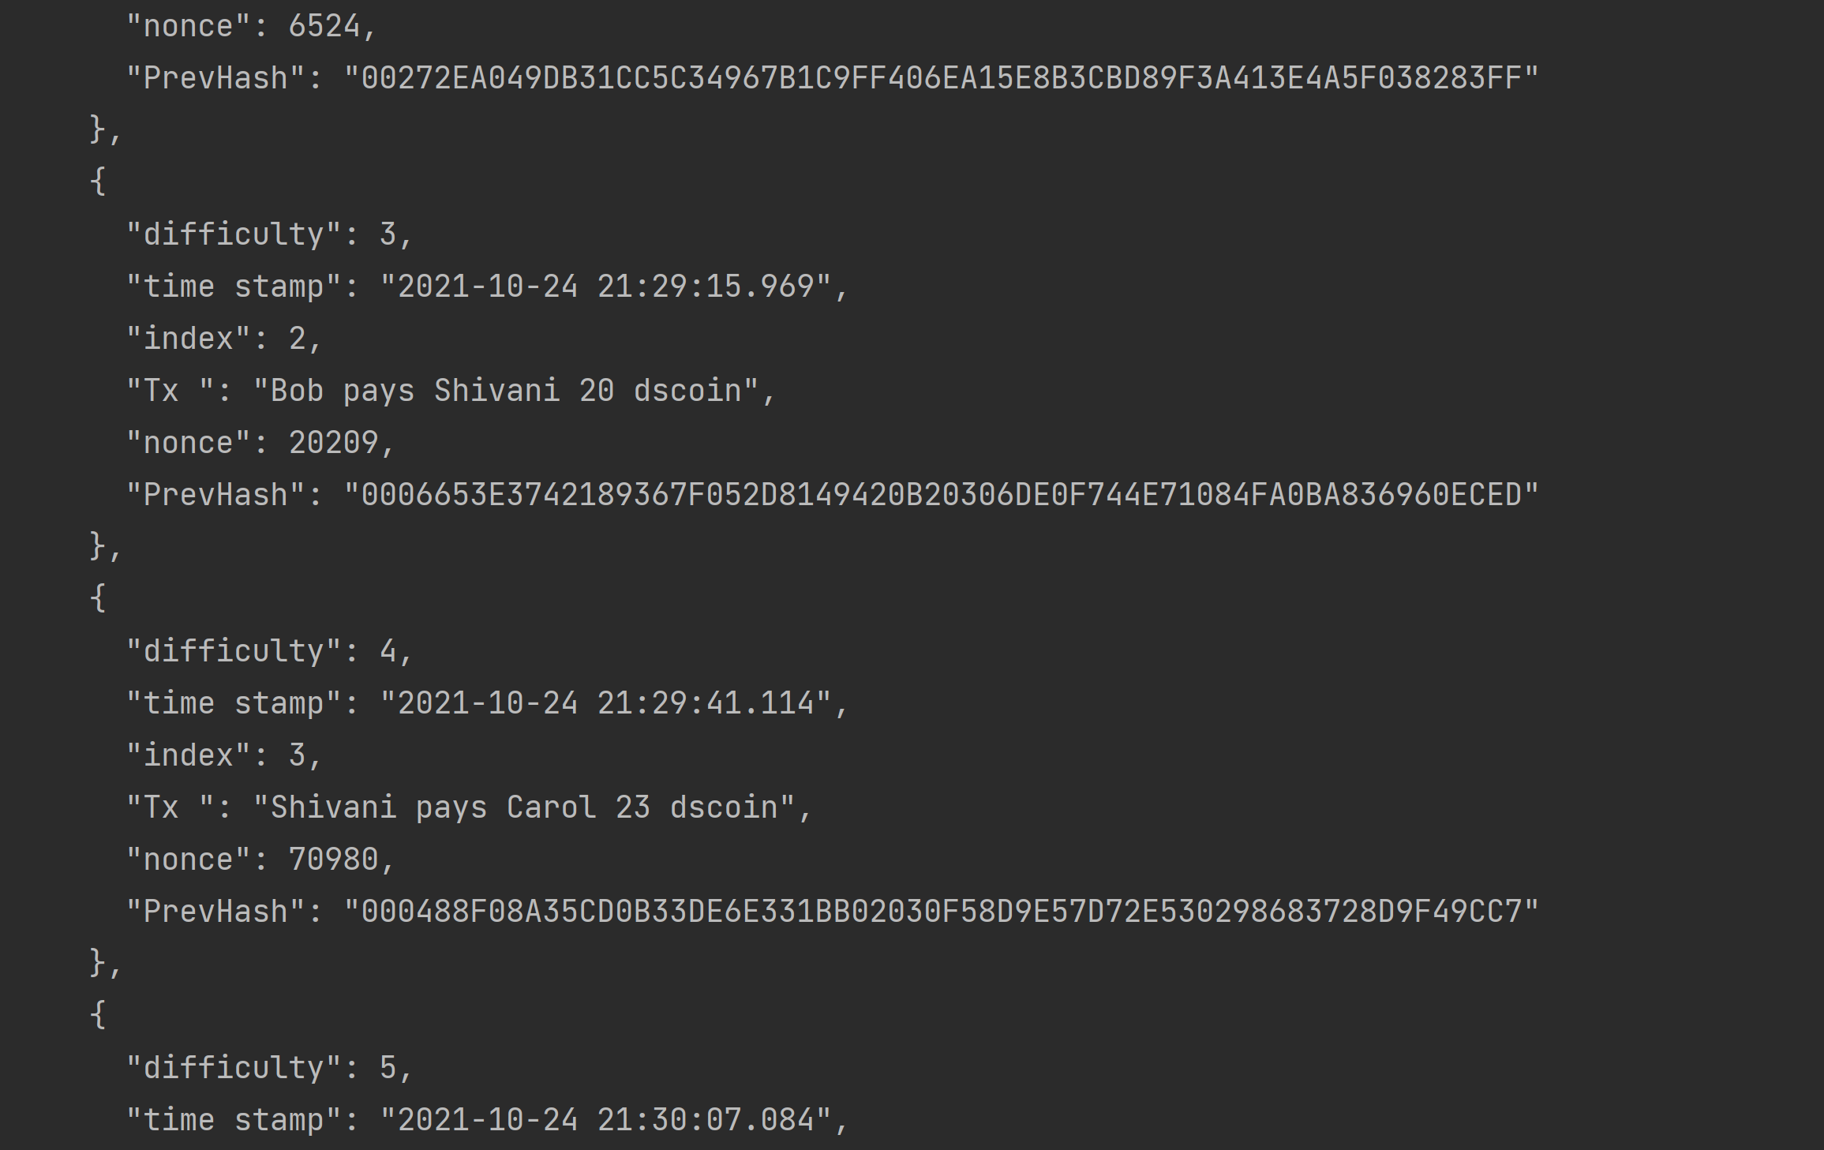

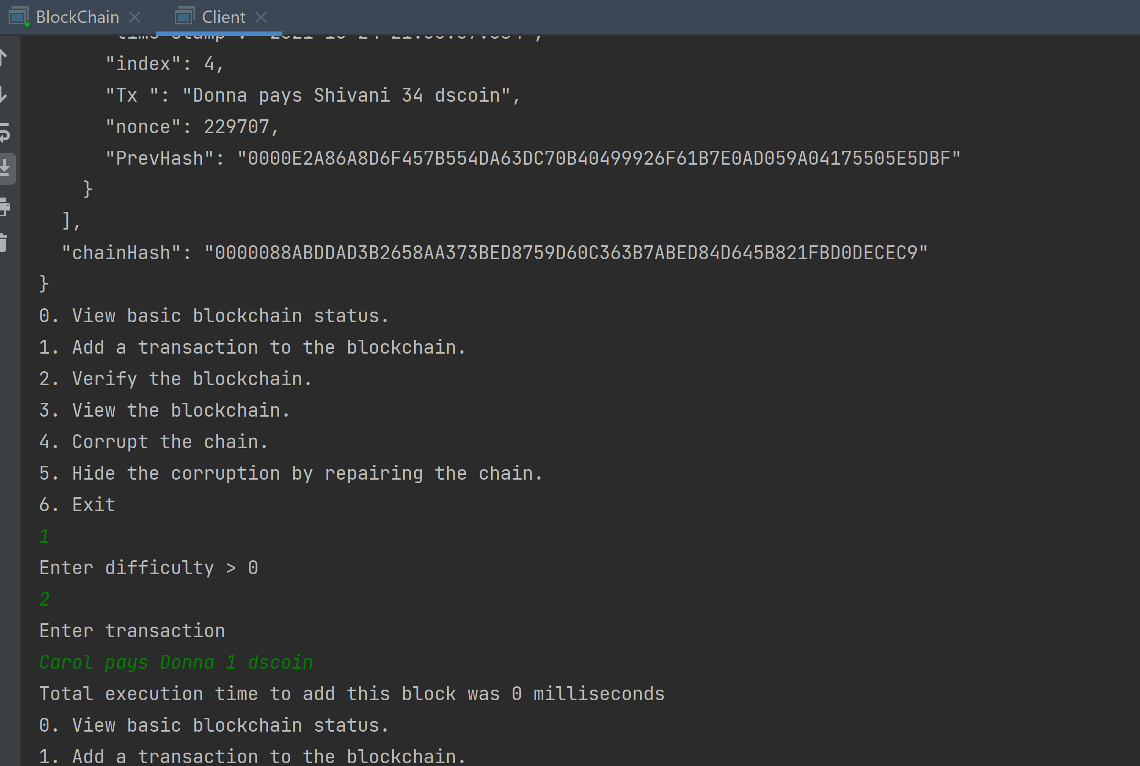

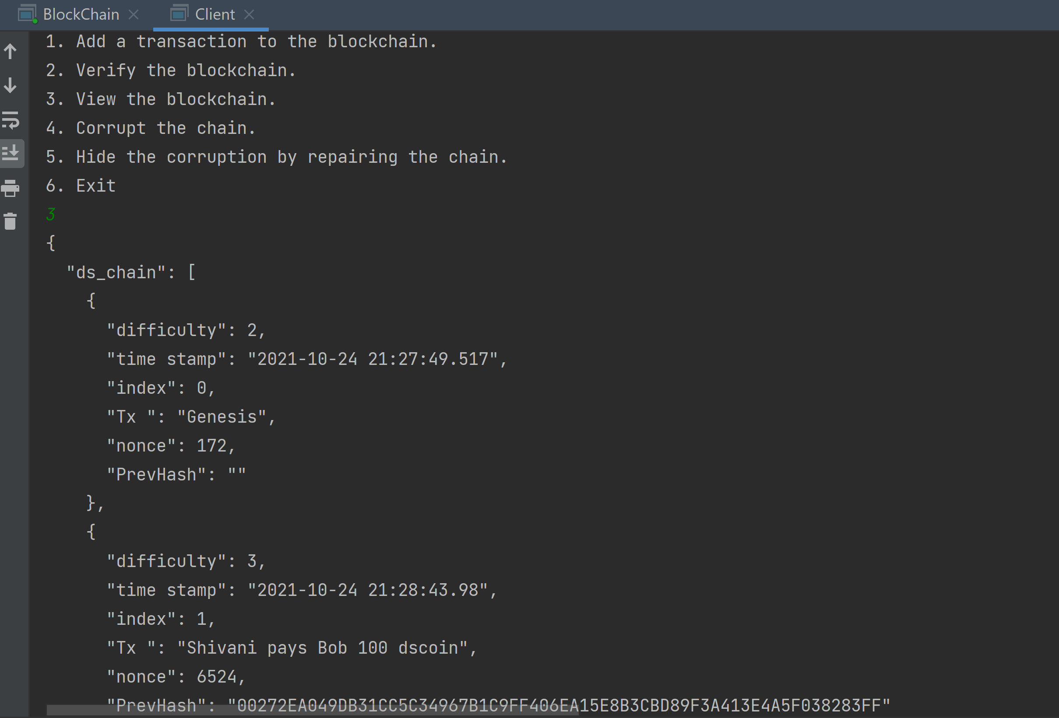

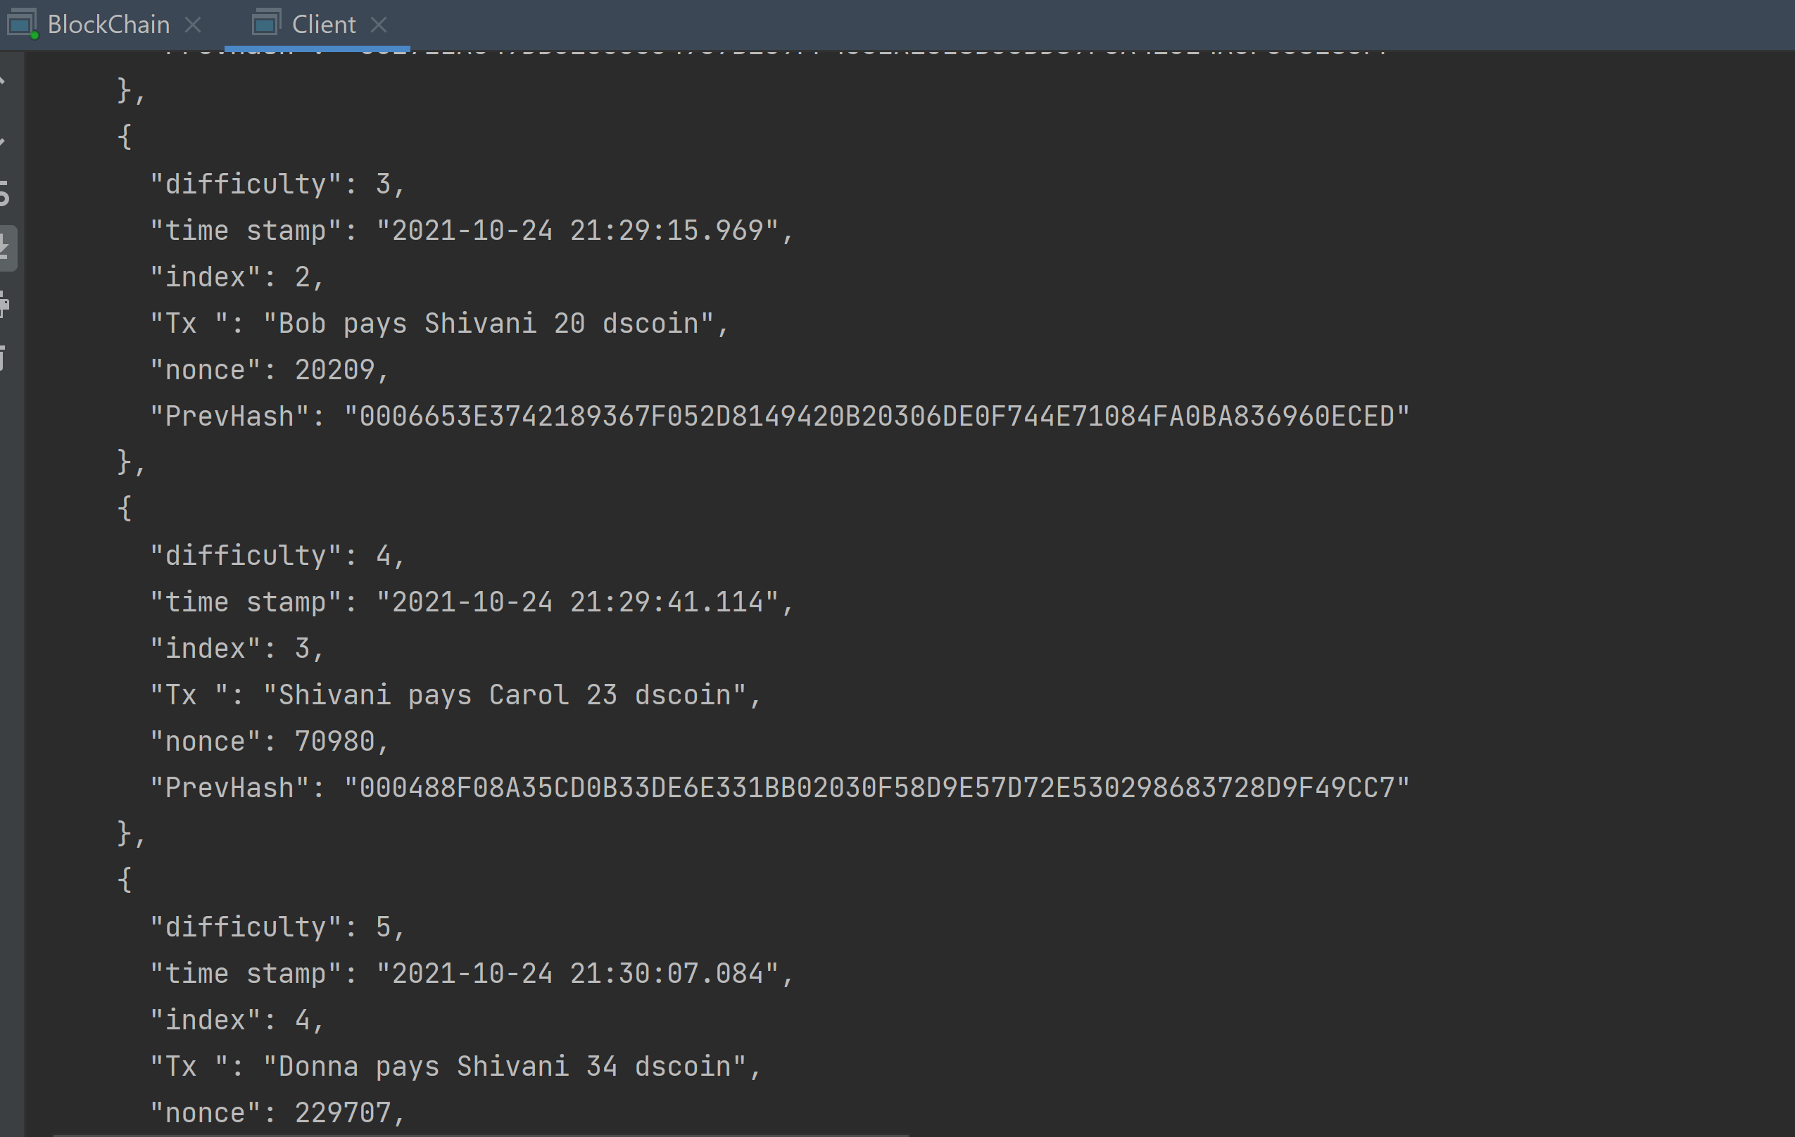

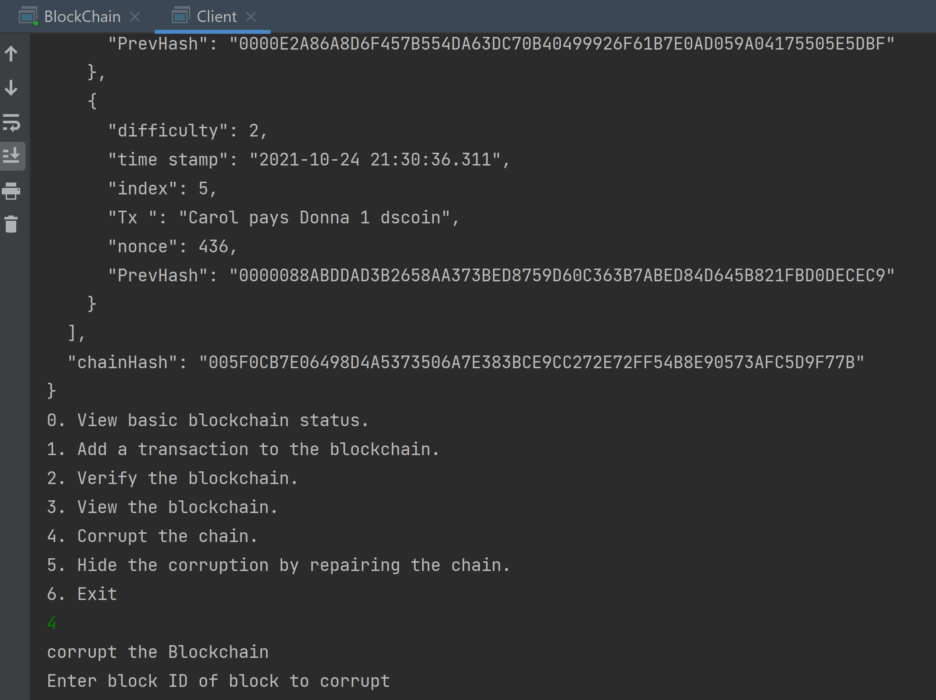

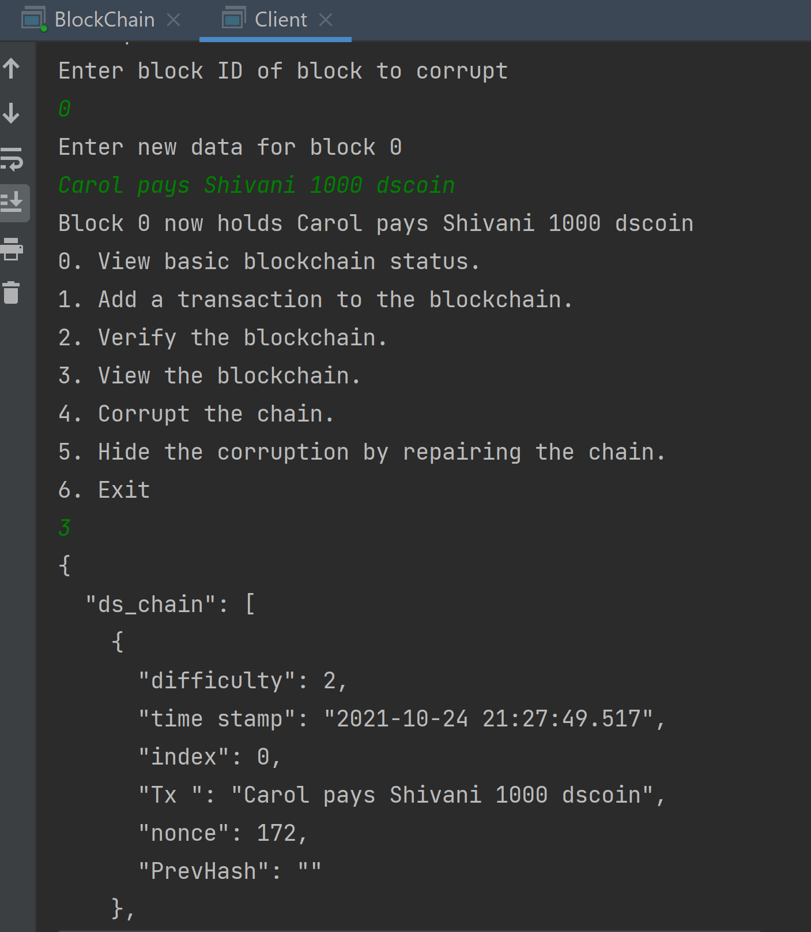

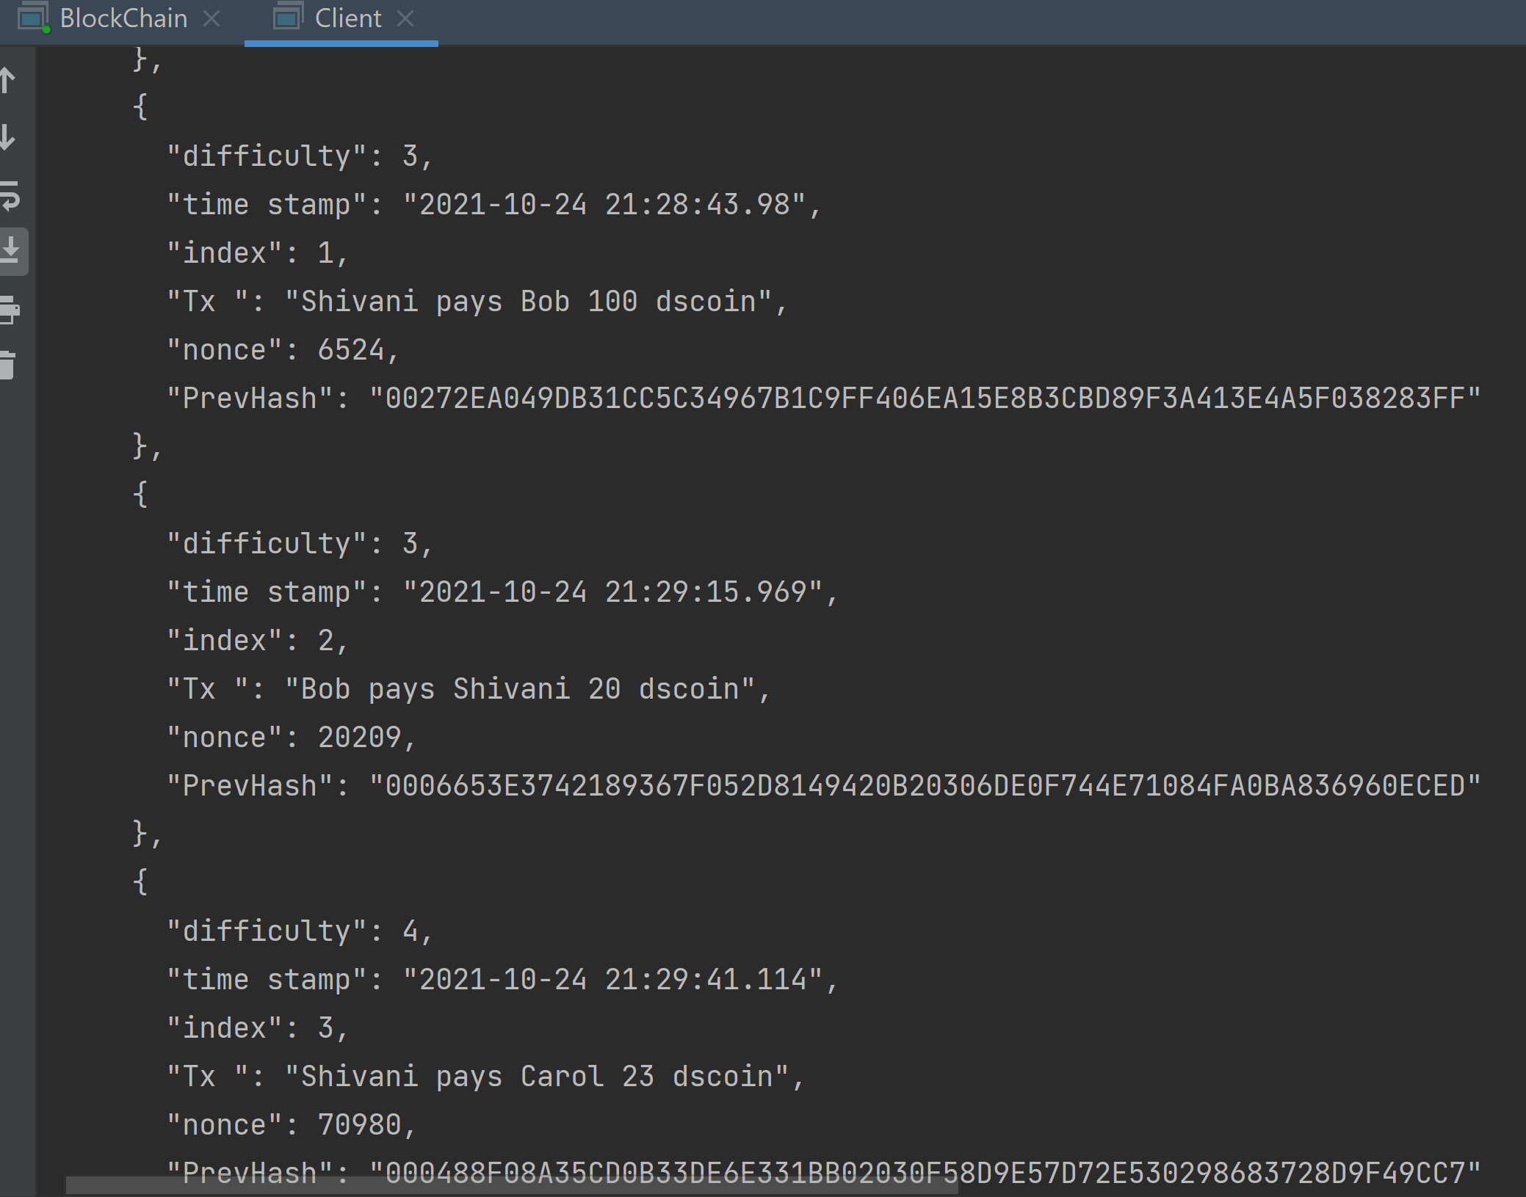

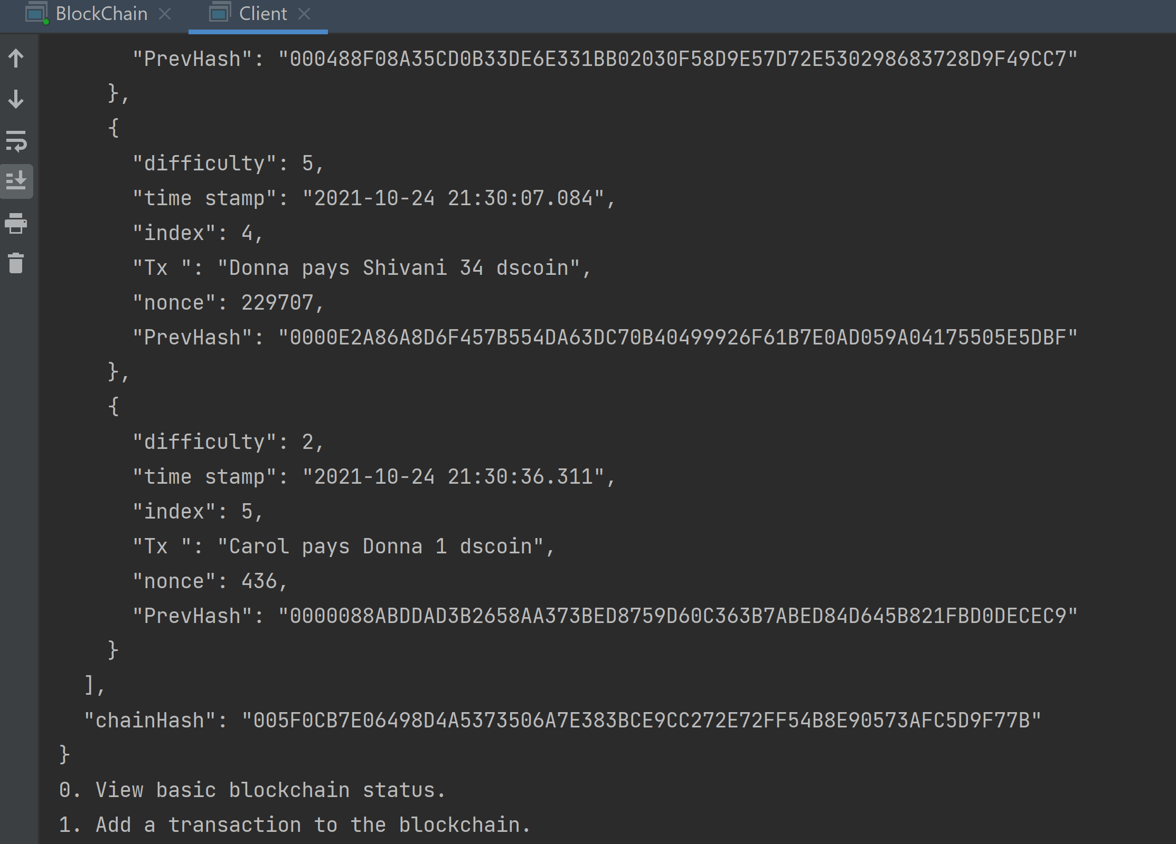

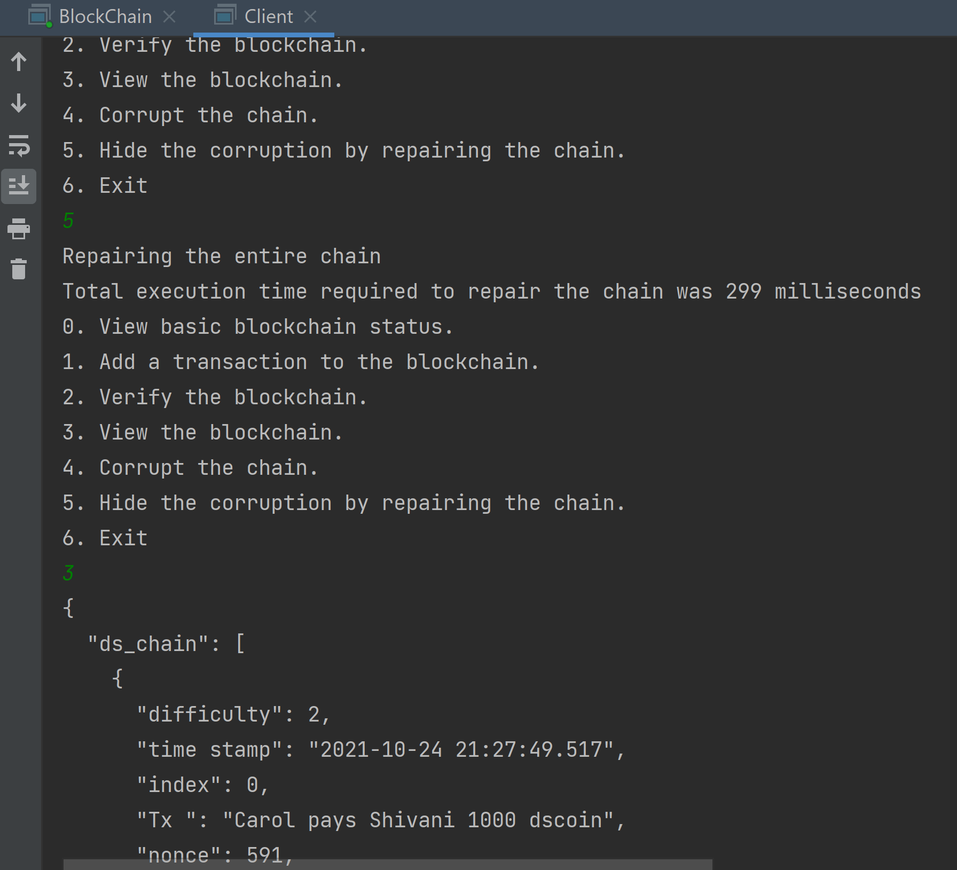

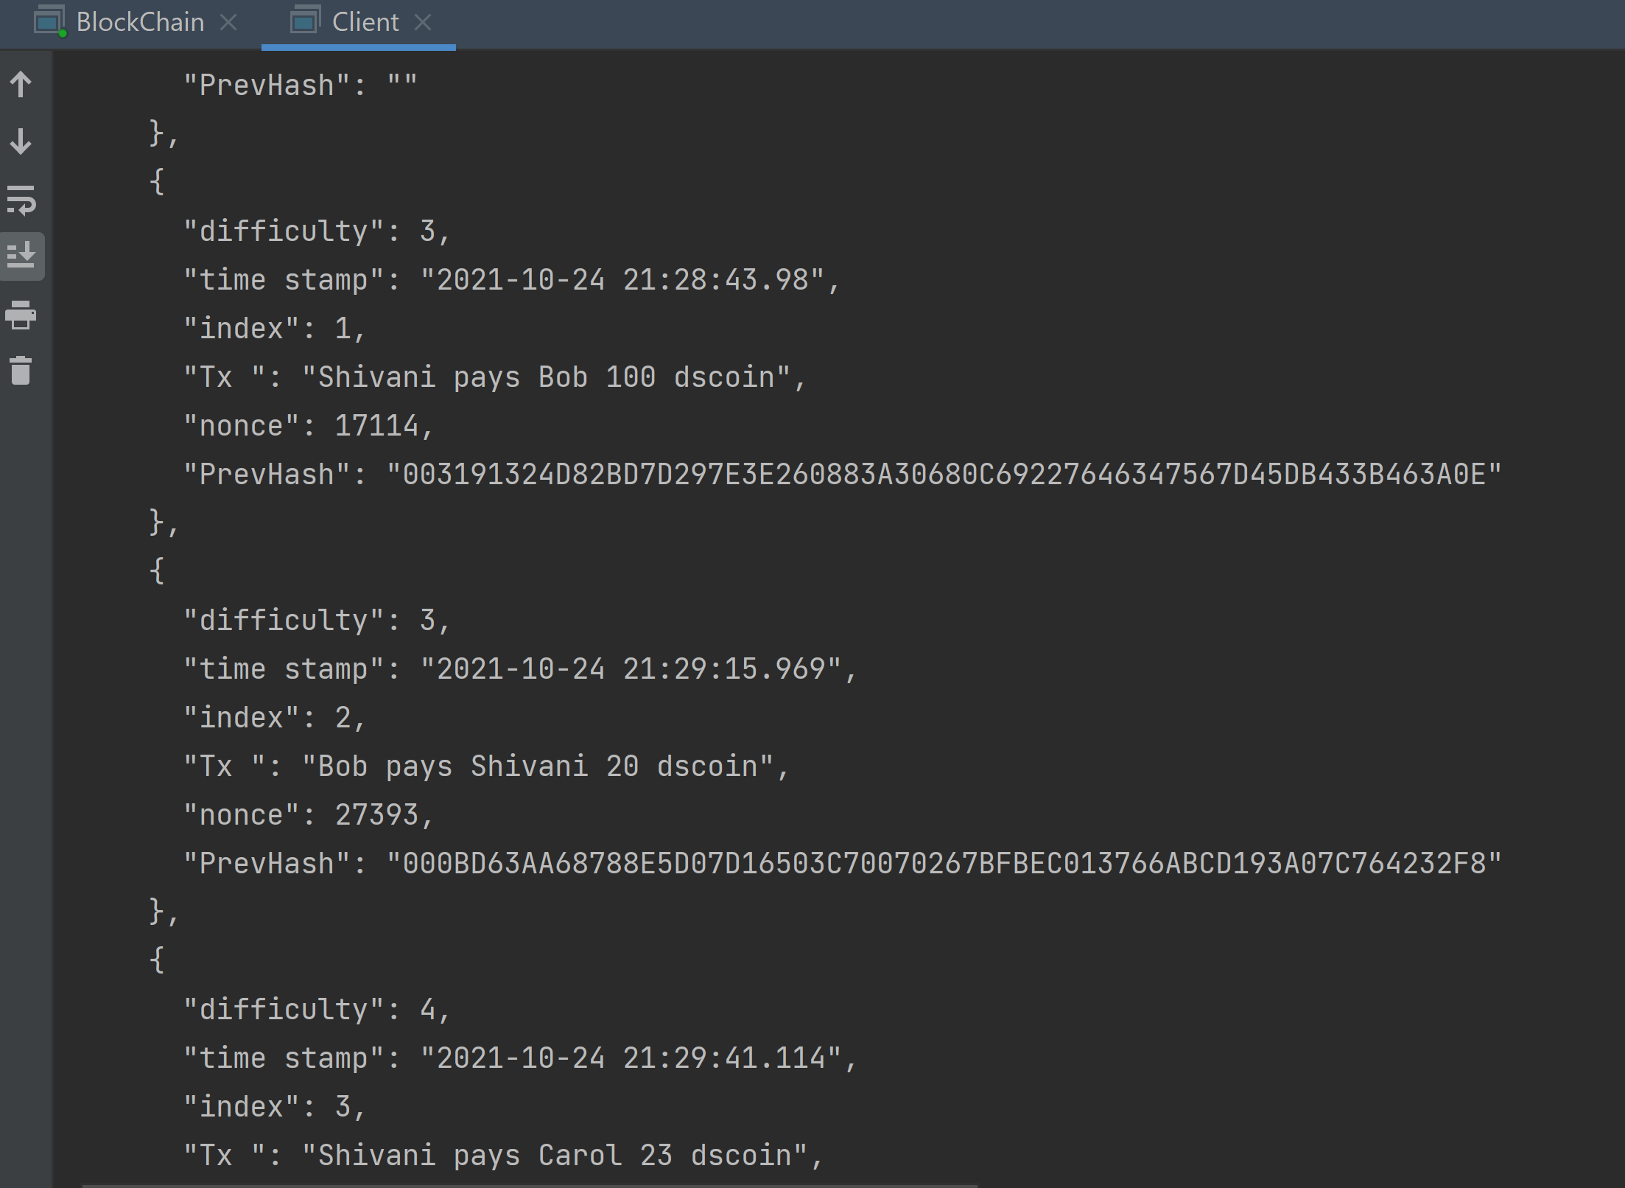

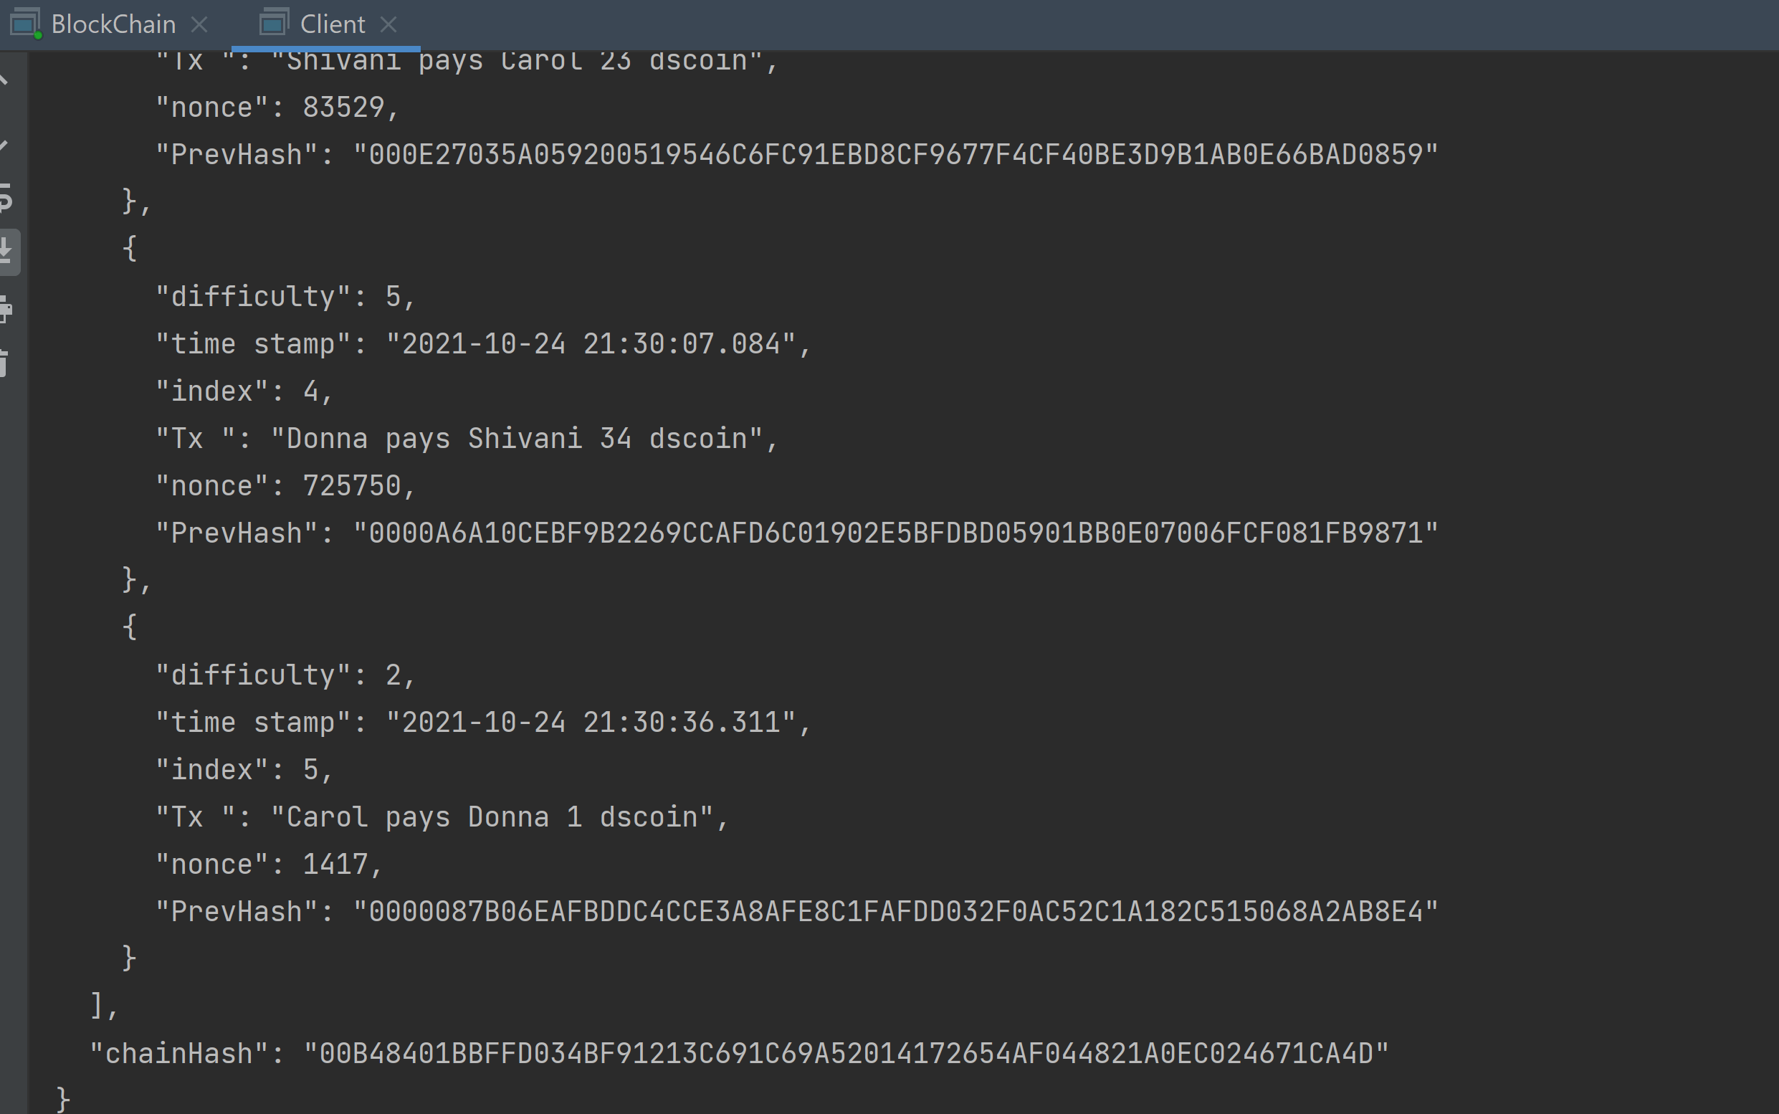

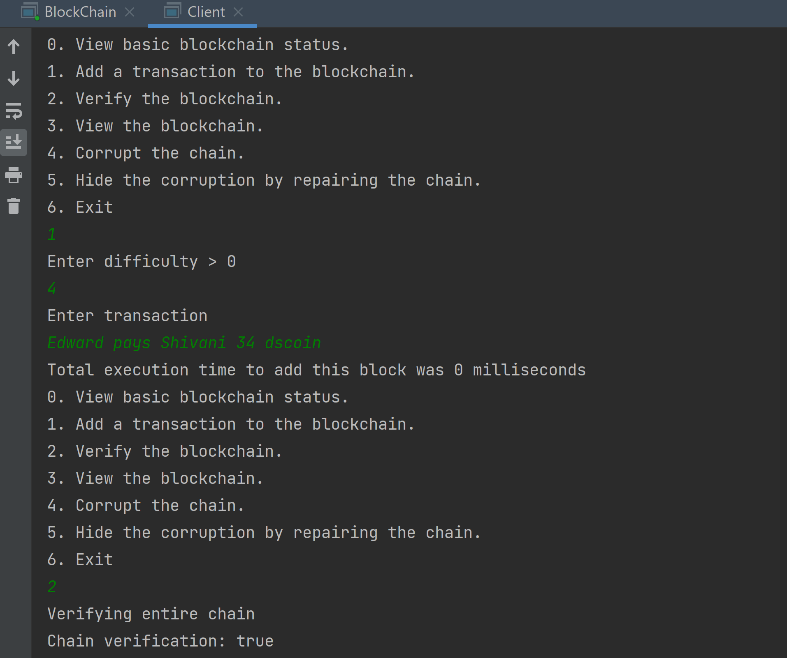

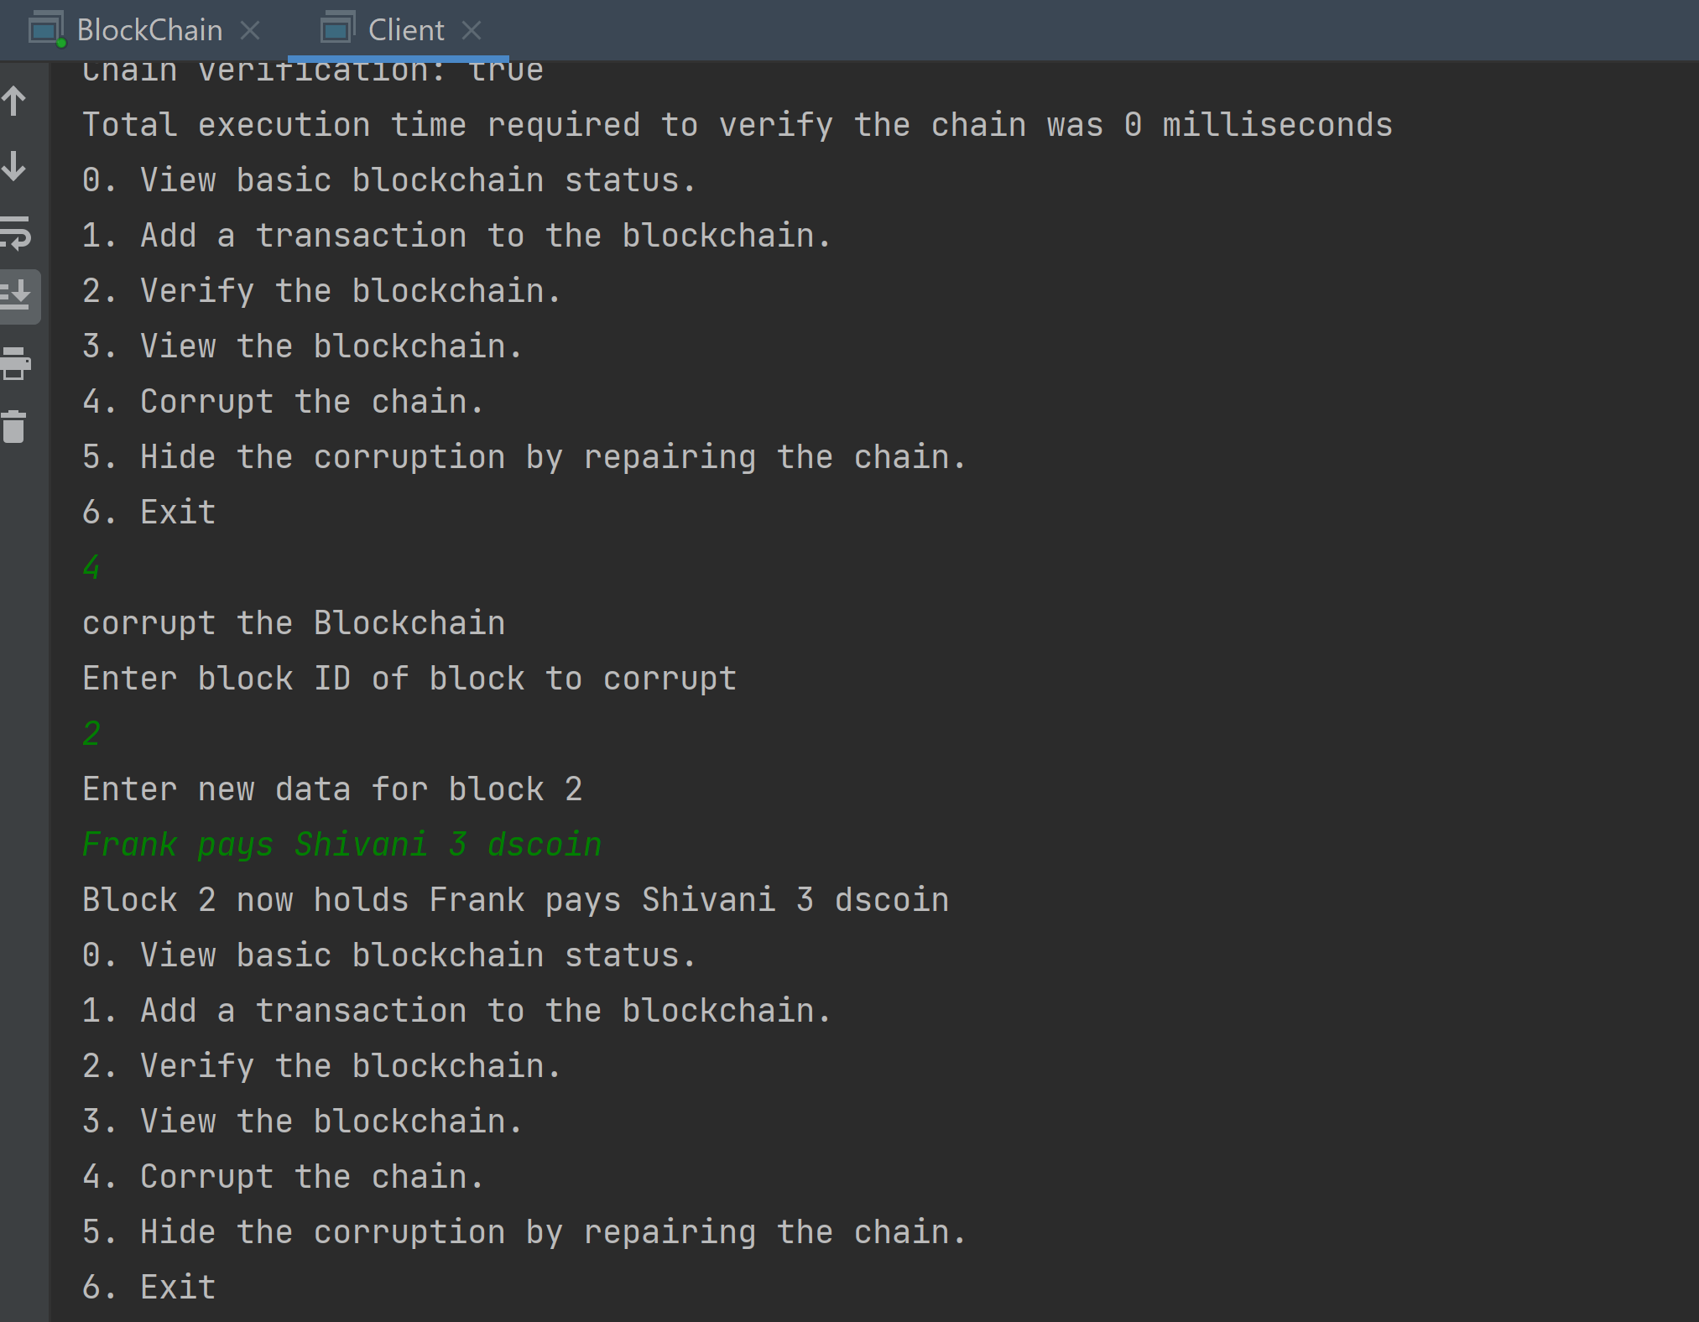

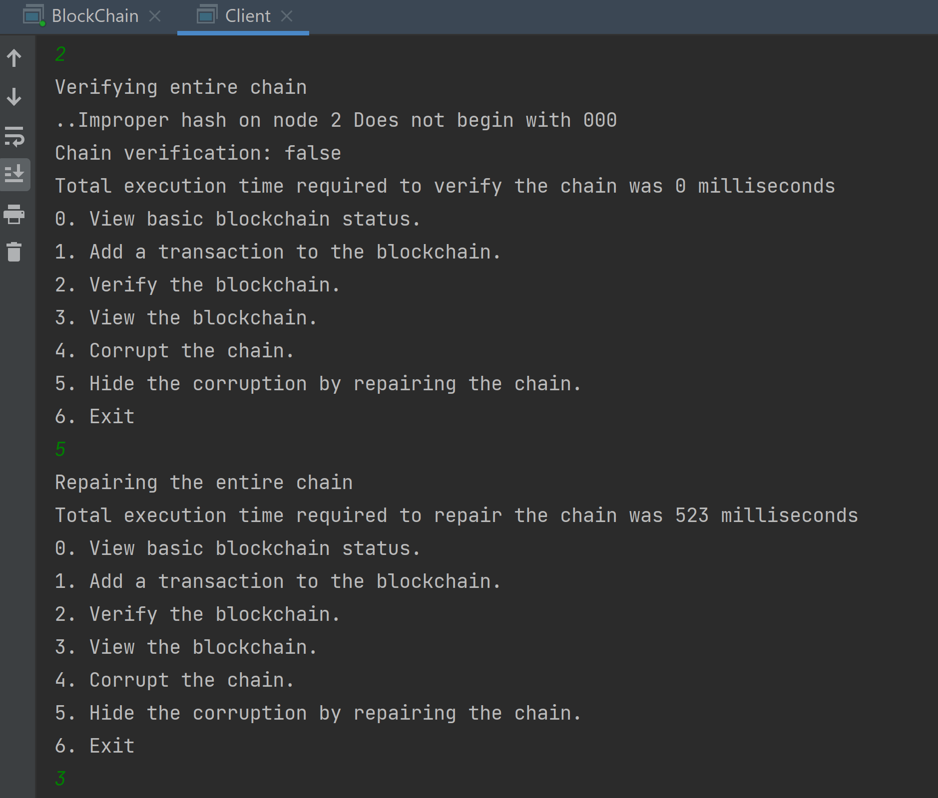

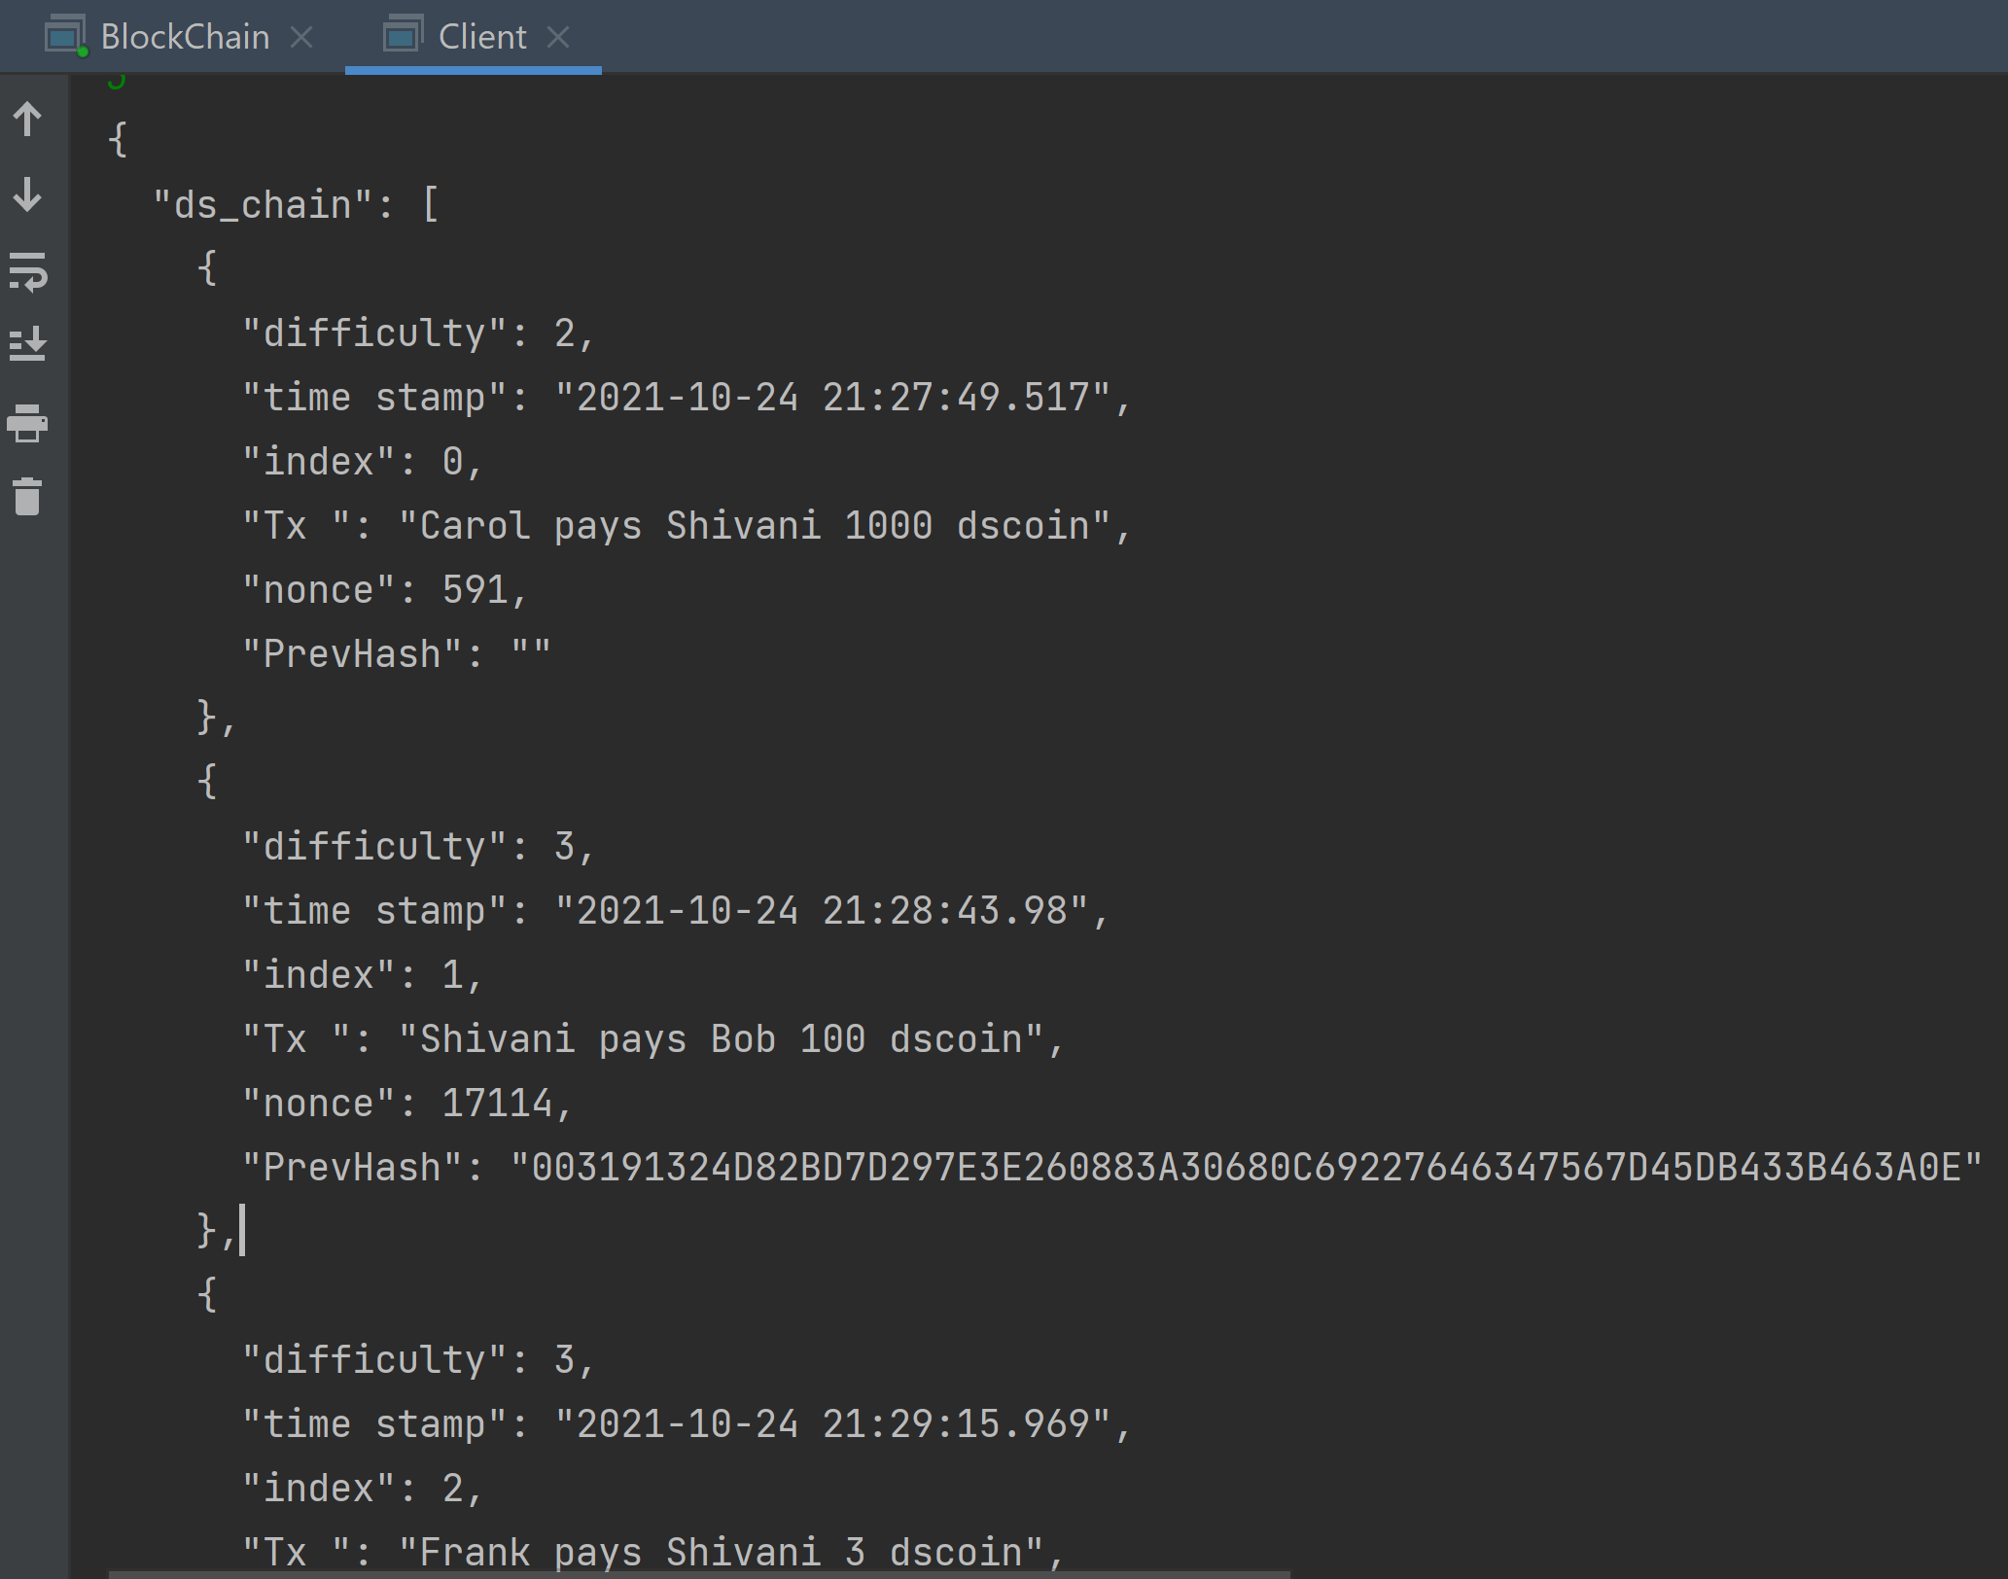

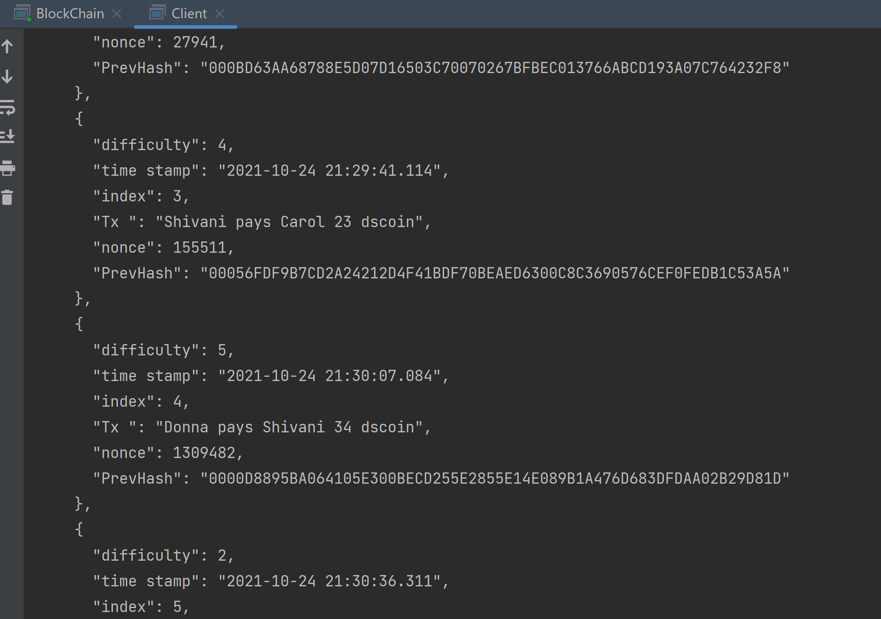

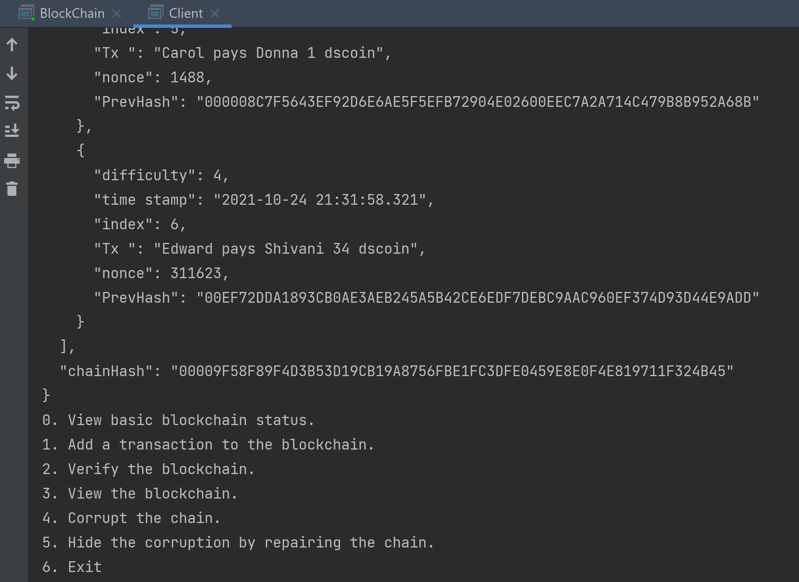

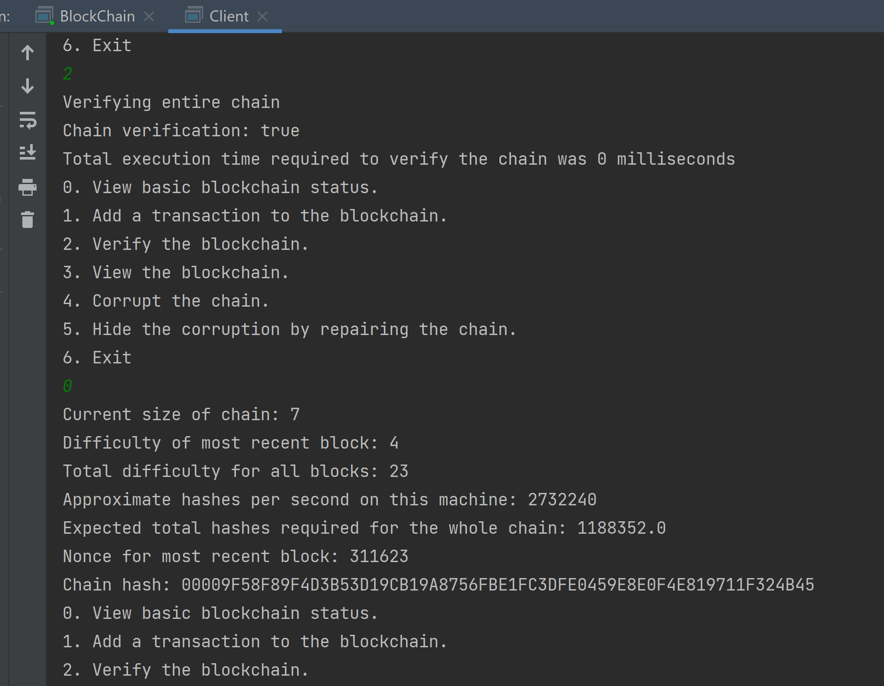

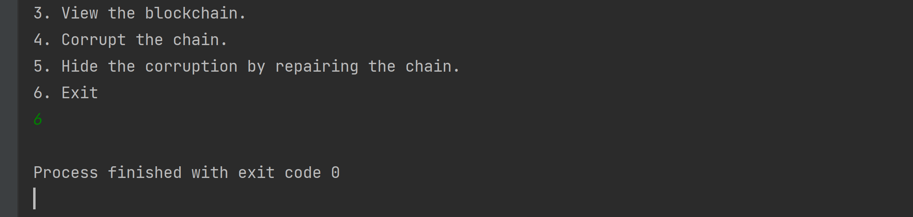

1. **Task 1 Client Source Code**

/*  
 * @author: Shivani Poovaiah Ajjikutira  
 * Last Modified: 24th October 2021  
 *  
 * This code forms the client for the interaction with the BlockChain class  
 * which serves as the server. The client takes in user input corresponding  
 * to the user choice as in Task 0 and based on the user input, takes other  
 * necessary details form the user and passed the data in JSON format converted  
 * to a string to the server. The GSON library and JSONObject libraries are  
 * imported to help form the JSON Object and parse the JSON.  
 * The client socket is initialized and forms a  
 * connection with the server socket having port number 7777.The client passes  
 * the data entered by the user to the server via the socket connection formed.  
 * The operation logic happens in the server. The program runs till the user chooses  
 * option 6, i.e, exit. When the user enters 6 the connection is terminated,however,  
 * the server continues running.  
 * */  
  
import com.google.gson.*;  
import org.json.simple.JSONObject;  
  
import java.io.*;  
import java.net.Socket;  
import java.net.SocketException;  
import java.util.Scanner;  
  
public class Client {  
  
 /*  
 * Method takes user input and passes data to the getResult method  
 * which interacts with the server and returns data as sent from  
 * the server. The data is then printed according to needed format  
 * using printOutput method. The process continues as long as user  
 * does not enter 6, i.e, Exit  
 * */  
 public static void main(String [] args) {  
 try {  
 // stores user choice  
 int userInput = -1;  
 while (userInput != 6) {  
 // displays menu options  
 *displayMenu*();  
 // Scanner to get user input from console  
 Scanner getInput = new Scanner(System.*in*);  
 userInput = Integer.*parseInt*(getInput.nextLine());  
 // gets all necessary data from user and send to getResult method  
 // and getResult method returns data sent by server  
 String output = *getResult*(*getOperationData*(userInput, getInput));  
 // to print data sent by server  
 *printOutput*(output);  
 }  
 } catch (IOException e) {  
 System.*out*.println("IO Exception: "+e.getMessage());  
 } catch (Exception e) {  
 System.*out*.println("Exception: "+e.getMessage());  
 }  
 }  
  
 // this method parses the json string passed to print the output as required  
 // by parsing the contents of the json  
 // Code from :  
 // https://stackoverflow.com/questions/5490789/json-parsing-using-gson-for-java  
 private static void printOutput(String output) {  
 // JSON parser  
 JsonElement jsonElement = new JsonParser().parse(output);  
 // creating JSONObject after parsing  
 JsonObject jsonObject = jsonElement.getAsJsonObject();  
 int userInput = jsonObject.get("user_input").getAsInt();  
 switch (userInput) {  
 case 0 -> {  
 System.*out*.println("Current size of chain: " + jsonObject.get("chain_size").getAsString());  
 System.*out*.println("Difficulty of most recent block: " + jsonObject.get("latest_difficulty").getAsString());  
 System.*out*.println("Total difficulty for all blocks: " + jsonObject.get("total_difficulty").getAsString());  
 System.*out*.println("Approximate hashes per second on this machine: " + jsonObject.get("hash_per_sec").getAsString());  
 System.*out*.println("Expected total hashes required for the whole chain: " + jsonObject.get("total_exp_hash").getAsString());  
 System.*out*.println("Nonce for most recent block: " + jsonObject.get("latest_nonce").getAsString());  
 System.*out*.println("Chain hash: " + jsonObject.get("chain_hash").getAsString());  
 }  
 case 1 -> System.*out*.println("Total execution time to add this block was " + jsonObject.get("computation_time").getAsString() + " milliseconds");  
 case 2 -> {  
 boolean isChainVerified =jsonObject.get("chain_verified").getAsBoolean();  
 if (!isChainVerified) {  
 int incorrectNode = jsonObject.get("incorrect_node").getAsInt();  
 int difficulty = jsonObject.get("difficulty").getAsInt();  
 System.*out*.printf("..Improper hash on node %d Does not begin with %s\n", incorrectNode, "0".repeat(Math.*max*(0, difficulty)));  
 }  
 System.*out*.println("Chain verification: " + isChainVerified);  
 System.*out*.println("Total execution time required to verify the chain was " + jsonObject.get("computation_time").getAsString() + " milliseconds");  
 }  
 case 3 -> {  
 // Code from https://stackoverflow.com/questions/4105795/pretty-print-json-in-java  
 // prettifying JSON to print content one below the other  
 Gson gson = new GsonBuilder().setPrettyPrinting().create();  
 String prettyJson = gson.toJson(new JsonParser().parse(jsonObject.get("output_json").getAsString()));  
 System.*out*.println(prettyJson);  
 }  
 case 4 -> {  
 int blockId = jsonObject.get("block_id").getAsInt();  
 String blockTransaction = jsonObject.get("block_transaction").getAsString();  
 System.*out*.printf("Block %d now holds %s\n", blockId, blockTransaction);  
 }  
 case 5 -> System.*out*.printf("Total execution time required to repair the chain was %s milliseconds\n", jsonObject.get("computation_time").getAsString());  
 }  
 }  
  
 /*  
 * This method is used to create connection with the server and  
 * pass the data to the server to perform the operation selected  
 * by user and returned required data. The client Socket is initialized with  
 * source and destination. The BufferedReader in is used to read data sent from the  
 * server and the PrintWriter out is used to write into the socket. The payload is written  
 * into the socket using the PrintWriter out. On using out.flush() the data in the stream  
 * is sent to the server to perform the logic. The reply sent by the server is read using  
 * the BufferedReader in and returned to the calling method,i.e., the main method  
 * */  
 public static String getResult(String payload) throws IOException {  
 // Code from EchoClientTCP.java in Project 2  
 // client socket declared  
 Socket clientSocket = null;  
 try {  
 // server port number  
 int serverPort = 7777;  
 // client socket initialized  
 clientSocket = new Socket("localhost", serverPort);  
 // read data from socket  
 BufferedReader in = new BufferedReader(new InputStreamReader(clientSocket.getInputStream()));  
 // write data to socket  
 PrintWriter out = new PrintWriter(new BufferedWriter(new OutputStreamWriter(clientSocket.getOutputStream())));  
 // write into socket  
 out.println(payload);  
 // send data written to server socket  
 out.flush();  
 // return data to main method  
 return in.readLine();  
 } catch (SocketException e) {  
 // to catch errors when errors occur with the network  
 System.*out*.println("Socket: " + e.getMessage());  
 } finally {  
 // close socket connection  
 if(clientSocket!=null) clientSocket.close();  
 }  
 return null;  
 }  
  
 // this method gets other details from the user based on the menu option selected.  
 // The data collected is made into a JSON object and the JSON string is then  
 // returned to the calling method, i.e, the getResult method.  
 // Code from https://stackoverflow.com/questions/5490789/json-parsing-using-gson-for-java  
 private static String getOperationData(int userInput,Scanner getUserInput) {  
 // new JSON Object created  
 JSONObject json = new JSONObject();  
 // add user input to JSON  
 json.put("user_input",userInput);  
 switch (userInput) {  
 case 1 -> {  
 System.*out*.println("Enter difficulty > 0");  
 int difficulty = Integer.*parseInt*(getUserInput.nextLine());  
 System.*out*.println("Enter transaction");  
 String transaction = getUserInput.nextLine();  
 // add difficulty to JSON object  
 json.put("difficulty",difficulty);  
 // add transaction to JSON object  
 json.put("transaction",transaction);  
 }  
 case 2 -> System.*out*.println("Verifying entire chain");  
 case 4 -> {  
 System.*out*.println("corrupt the Blockchain\n" +  
 "Enter block ID of block to corrupt");  
 int blockId = Integer.*parseInt*(getUserInput.nextLine());  
 System.*out*.println("Enter new data for block " + blockId);  
 String blockTransaction = getUserInput.nextLine();  
 // add blockId to JSON object  
 json.put("block_id",blockId);  
 // add blockTransaction to JSON object  
 json.put("block_transaction",blockTransaction);  
 }  
 case 5 -> System.*out*.println("Repairing the entire chain");  
 }  
 // return JSON string  
 return json.toString();  
 }  
  
 // displays menu options to the user  
 public static void displayMenu() {  
 System.*out*.println("""  
 0. View basic blockchain status.  
 1. Add a transaction to the blockchain.  
 2. Verify the blockchain.  
 3. View the blockchain.  
 4. Corrupt the chain.  
 5. Hide the corruption by repairing the chain.  
 6. Exit""");  
 }  
}

1. **Task 1 Server Source Code**

/*  
 * @author: Shivani Poovaiah Ajjikutira  
 * Last Modified: 24th October 2021  
 *  
 * This code follows Task 0 but uses TCP for the data transmission between the client  
 * and server. The following code is the server side for the program.  
 * The server socket is initialized and continues to listen to any  
 * request sent by client sockets connected to port number 7777.The server  
 * receives the data from the client through Scanner "in" via the socket connection  
 * formed. The PrintWriter "out" is used to write into the stream and send data  
 * back to the requesting client. The performOperations method checks the operation  
 * passed and does the required logic on the blockchain.The server is always running.  
 * Explanation and code taken from JavaDoc -  
 * https://www.andrew.cmu.edu/course/95-702/examples/javadoc/blockchaintask0/BlockChain.html#isChainValid()  
 * This is the code for Blockchain. It will begin by creating a BlockChain object  
 * and then adding the Genesis block to the chain. The Genesis block will be created with an empty string  
 * as the previous hash and a difficulty of 2. On start up, this code will also establish the hashes per  
 * second instance member. All blocks added to the Blockchain will have a difficulty passed by the  
 * client. All hashes will have the proper number of zero hex digits representing  
 * the most significant nibbles in the hash. A nibble is 4 bits. If the difficulty is specified as three,  
 * then all hashes will begin with 3 or more zero hex digits (or 3 nibbles, or 12 zero bits).  
 * It is menu-driven and based on the user selection, different data is sent from the client and  
 * certain operations are performed on the blockchain on the server side.  
 * */  
  
import org.json.simple.JSONArray;  
import org.json.simple.JSONObject;  
import com.google.gson.*;  
  
import java.io.BufferedWriter;  
import java.io.IOException;  
import java.io.OutputStreamWriter;  
import java.io.PrintWriter;  
import java.net.ServerSocket;  
import java.net.Socket;  
import java.net.SocketException;  
import java.nio.charset.StandardCharsets;  
import java.security.MessageDigest;  
import java.security.NoSuchAlgorithmException;  
import java.sql.Timestamp;  
import java.util.*;  
  
public class BlockChain {  
 // ArrayList to hold Blocks  
 private final ArrayList<Block> blocks;  
 // holds a SHA256 hash of the most recently added Block.  
 private String chainHash;  
 // Store hashes per second  
 private static int *hashesPerSecond*;  
 // store node having wrong hash  
 private int incorrectNode;  
  
 // constructor  
 BlockChain() {  
 // initialize blocks ArrayList, chainHash and hashesPerSecond  
 blocks= new ArrayList<>();  
 chainHash = "";  
 *hashesPerSecond*=0;  
 }  
  
 /*  
 * On startup the genesis block is created and added to the blockchain. Based on the data  
 * sent from the client different operations are performed in the performOperations method.  
 *  
 * Based on the experiments conducted the computation time increases as the difficulty associated  
 * with the block increases. For instance, for difficulty 2, addBlock() methods takes between  
 * 0-15 milliseconds approximately. For difficulty 5, addBlock() methods took 461 milliseconds  
 * approximately. For difficulty 6, addBlock() methods took 6000 milliseconds approximately.  
 * The repairChain() and isChainValid methods take approximately 0 milliseconds if all the blocks  
 * have correct data irrespective of the difficulty of the blocks. However, in the presence of a  
 * malicious block having corrupt data, repairChain() method takes longer time if there are blocks  
 * with higher difficulty. For instance, if malicious block has a difficulty of 2, the  
 * repairChain() method took 2775 milliseconds. But if malicious block has a difficulty of 6, the  
 * repairChain() method took 13221 milliseconds. isChainValid() method also takes longer time  
 * if malicious block has higher difficulty. For difficulty 2 of malicious block, isChainValid()  
 * method took close to 0 milliseconds and for difficulty 6, method took close to 362 milliseconds.  
 * */  
 public static void main(String[] args){  
 BlockChain blockChain = new BlockChain();  
 Block genesisBlock = new Block(0, new Timestamp(new Date().getTime()), "Genesis", 2);  
 genesisBlock.setPreviousHash("");  
 blockChain.computeHashesPerSecond();  
 blockChain.addBlock(genesisBlock);  
 // Code from EchoServerTCP.java in Project 2  
 System.*out*.println("Server started");  
 // client socket declared  
 Socket clientSocket = null;  
 try{  
 int serverPort = 7777; // the server port number  
  
 // Create a new server socket with port number 7777  
 ServerSocket listenSocket = new ServerSocket(serverPort);  
  
 // Since server is always running and listens for requests  
 while(true){  
 /*  
 * Block waiting for a new connection request from a client.  
 * When the request is received, "accept" it, and the rest  
 * the tcp protocol handshake will then take place, making  
 * the socket ready for reading and writing.  
 */  
 if(clientSocket==null || clientSocket.getInputStream().read() == -1)  
 clientSocket = listenSocket.accept();  
 // If we get here, then we are now connected to a client.  
  
 // Set up "in" to read from the client socket  
 Scanner in;  
 in = new Scanner(clientSocket.getInputStream());  
  
 // Set up "out" to write to the client socket  
 PrintWriter out;  
 out = new PrintWriter(new BufferedWriter(new OutputStreamWriter(clientSocket.getOutputStream())));  
 // read from client socket  
 String data = in.nextLine();  
 // result stores JSON string returned by performOperations method  
 String result = blockChain.performOperations(data);  
 // write to client socket  
 out.println(result);  
 // send data written to client socket  
 out.flush();  
 }  
 } catch (SocketException e) {  
 // to catch errors when errors occur with the network  
 System.*out*.println("Socket: " + e.getMessage());  
 }catch (IOException e){  
 // to catch errors when there is an input-output exception  
 System.*out*.println("IO: " + e.getMessage());  
 }  
 }  
  
 // check the proofOfWork for each block and add it to the blockchain, update  
 // chain hash with the latest added block's proofOfWork  
 public void addBlock (Block newBlock) {  
 if(blocks.size()!=0) newBlock.setPreviousHash(getBlock(blocks.size()-1).proofOfWork());  
 blocks.add(newBlock);  
 chainHash = newBlock.proofOfWork();  
 }  
  
 // getter for timestamp  
 public Timestamp getTime() {  
 return new Timestamp(new Date().getTime());  
 }  
  
 // getter for latest block  
 public Block getLatestBlock() {  
 return getBlock(blocks.size()-1);  
 }  
  
 // getter for chain size  
 public int getChainSize() {  
 return blocks.size();  
 }  
  
 /*  
 * This method computes exactly 1 million hashes and times how long that process takes.  
 * So, hashes per second is approximated as (1 million / number of seconds). It is run on start  
 * up and sets the instance variable hashesPerSecond. It uses a simple string -  
 * "00000000" to hash.*/  
 public void computeHashesPerSecond() {  
 String sampleString = "00000000";  
 long startTime = getTime().getTime();  
 byte[] bytesOfHash = sampleString.getBytes(StandardCharsets.*UTF_8*);  
 for(int i=0; i<1000000;i++) {  
 try {  
 // Use SHA-256 for hashing  
 MessageDigest md = MessageDigest.*getInstance*("SHA-256");  
 md.digest(bytesOfHash);  
 } catch (NoSuchAlgorithmException e) {  
 e.printStackTrace();  
 }  
 }  
 long endTime = getTime().getTime();  
 BlockChain.*hashesPerSecond* = (int) (1000000*1000/ (double) (endTime - startTime));  
 }  
  
 // getter for hashes per second  
 public int getHashesPerSecond() {  
 return *hashesPerSecond*;  
 }  
  
 // creates string in json format for entire blockchain using toString method of  
 // individual blocks  
 public String toString() {  
 System.*out*.println("View the Blockchain");  
 JSONArray jsonBlocks = new JSONArray();  
 for(int i=0; i<blocks.size();i++) {  
 Block block = getBlock(i);  
 JsonElement jsonElement = new JsonParser().parse(block.toString());  
 jsonBlocks.add(jsonElement);  
 }  
 JSONObject outputJson = new JSONObject();  
 outputJson.put("ds_chain",jsonBlocks);  
 outputJson.put("chainHash",chainHash);  
 return outputJson.toString();  
 }  
  
 // getter for block at index i  
 public Block getBlock (int i) {  
 return blocks.get(i);  
 }  
  
 // compute and return the total difficulty of all blocks on the chain.  
 public int getTotalDifficulty() {  
 int totalDifficulty=0;  
 for(int i=0; i< blocks.size(); i++) {  
 totalDifficulty+=getBlock(i).getDifficulty();  
 }  
 return totalDifficulty;  
 }  
  
 // Compute and return the expected number of hashes required for the entire chain.  
 public double getTotalExpectedHashes() {  
 double totalExpectedHashes = 0;  
 for(int i=0; i<blocks.size();i++) {  
 totalExpectedHashes += Math.*pow*((16),getBlock(i).getDifficulty());  
 }  
 return totalExpectedHashes;  
 }  
  
 /*  
 * If the chain only contains one block, the genesis block at position 0, this method computes  
 * the hash of the block and checks that the hash has the requisite number of leftmost 0's  
 * (proof of work) as specified in the difficulty field. It also checks that the chain hash  
 * is equal to this computed hash. If either check fails, return false. Otherwise, return true.  
 * If the chain has more blocks than one, begin checking all blocks using chainValidation  
 * method. If chainValidation method returns a non-negative number continue checking the  
 * blocks in the blockchain. When chainValidation method returns -1, then it means the  
 * chain validation fails. */  
 public boolean isChainValid() {  
 if(blocks.size()==1) {  
 Block genesis = getBlock(0);  
 String genesisHash = genesis.proofOfWork();  
 int numberOfZero = 0;  
 int difficulty = genesis.getDifficulty();  
 char[] charsHash = genesisHash.toCharArray();  
 for (int i = 0; i < difficulty; i++) {  
 if (charsHash[i] == '0') numberOfZero++;  
 }  
 return chainHash.equals(genesisHash) && numberOfZero == difficulty;  
 } else {  
 for(int i=0; i<blocks.size();i++) {  
 // checks each node  
 int node = chainValidation(i);  
 if(node==-1) {  
 // setting index of incorrect node with wrong hash value  
 incorrectNode=i-1;  
 return false;  
 }  
 }  
 return chainHash.equals(getLatestBlock().proofOfWork());  
 }  
 }  
  
 /*  
 * Check hash pointer of each Block and compare with proofOfWork of previous block.  
 * If they match and if the proof of work is correct, return block index. else  
 * return -1; */  
 public int chainValidation(int blockIndex) {  
 String prevBlockHash = blockIndex==0?  
 "":getBlock(blockIndex-1).proofOfWork();  
 String hashPointer = getBlock(blockIndex).getPreviousHash();  
 if(prevBlockHash.equals(hashPointer)) {  
 if(blockIndex!=0){  
 char[] charsHash = prevBlockHash.toCharArray();  
 int difficulty = getBlock(blockIndex-1).getDifficulty();  
 int numberOfZero = 0;  
 for (int i = 0; i < difficulty; i++) {  
 if (charsHash[i] == '0') numberOfZero++;  
 }  
 if (numberOfZero == difficulty) return blockIndex;  
 }  
 return blockIndex;  
 }  
 return -1;  
 }  
  
 // checks each block and recomputes proofOfWork for each block and  
 // assigns the correct hash pointer in the next block as well as the  
 // chain hash using the proofOfWork of the last added block.  
 public void repairChain() {  
 for(int i=0; i<getChainSize();i++) {  
 if(i==0) getBlock(i).setPreviousHash("");  
 String correctHash = getBlock(i).proofOfWork();  
 if(i+1 < getChainSize())getBlock(i+1).setPreviousHash(correctHash);  
 if(i==getChainSize()-1) chainHash=correctHash;  
 }  
 chainHash=getLatestBlock().proofOfWork();  
 }  
  
 // this method parses the json string sent from the client and  
 // performs the required operation by parsing through the  
 // json object. Further, it creates a new outputPayload  
 // json object,converts the json object to string inorder  
 // to send back to the requesting client  
 public String performOperations(String data) {  
 // JSON Parsing  
 JsonElement jsonElement = new JsonParser().parse(data);  
 // Creating JSON object from parsed string  
 JsonObject jsonObject = jsonElement.getAsJsonObject();  
 int userInput = jsonObject.get("user_input").getAsInt();  
 // JSON object to be returned to client  
 JSONObject outputPayload = new JSONObject();  
 // load output JSON with user input  
 outputPayload.put("user_input",userInput);  
 switch (userInput) {  
 case 0 -> {  
 // loads json with basic blockchain status  
 outputPayload.put("chain_size",getChainSize());  
 outputPayload.put("latest_difficulty",getLatestBlock().getDifficulty());  
 outputPayload.put("total_difficulty",getTotalDifficulty());  
 outputPayload.put("hash_per_sec",getHashesPerSecond());  
 outputPayload.put("total_exp_hash",getTotalExpectedHashes());  
 outputPayload.put("latest_nonce",getLatestBlock().getNonce());  
 outputPayload.put("chain_hash",chainHash);  
 }  
 case 1 -> {  
 // load output JSON with computation time after adding new block  
 long start = System.*currentTimeMillis*();  
 int difficulty =Integer.*parseInt*(jsonObject.get("difficulty").getAsString());  
 String transaction = jsonObject.get("transaction").getAsString();  
 addBlock(new Block(getLatestBlock().getIndex() + 1,  
 new Timestamp(new Date().getTime()), transaction, difficulty));  
 long end = System.*currentTimeMillis*();  
 outputPayload.put("computation_time",end-start);  
 }  
 case 2 -> {  
 // performs chain verification, loads output JSON with incorrectNode id  
 // and difficulty in case chain verification fails. load output JSON with  
 // computation time for the process as well  
 long start = System.*currentTimeMillis*();  
 boolean chainVerified = isChainValid();  
 outputPayload.put("chain_verified",chainVerified);  
 if (!chainVerified) {  
 int difficulty = getBlock(incorrectNode).getDifficulty();  
 outputPayload.put("incorrect_node",incorrectNode);  
 outputPayload.put("difficulty",difficulty);  
 }  
 long end = System.*currentTimeMillis*();  
 outputPayload.put("computation_time",end-start);  
 }  
 // loads output json with blockchain content  
 case 3 -> outputPayload.put("output_json",this.toString());  
 case 4 -> {  
 // updates block data based on block id and transaction passed from  
 // the client side and loads output json with the block id and transaction  
 int blockId = Integer.*parseInt*(jsonObject.get("block_id").getAsString());  
 String blockTransaction =jsonObject.get("block_transaction").getAsString();  
 getBlock(blockId).setData(blockTransaction);  
 outputPayload.put("block_id",blockId);  
 outputPayload.put("block_transaction",blockTransaction);  
 }  
 case 5 -> {  
 // repairs chain and loads output json with computation time needed  
 // for this process  
 long start = System.*currentTimeMillis*();  
 repairChain();  
 long end = System.*currentTimeMillis*();  
 outputPayload.put("computation_time",end-start);  
 }  
 }  
 // return json string  
 return outputPayload.toString();  
 }  
}